
SDI Industries - 3000 Pierce St. Pacoima, CA. 91331 - T: 818-890-6002 - F: 818-890-2858

CSS
Sistema de triagem Carton
Guia de Treinamento

April 1, 2013

NOTICE
THIS DOCUMENT BELONGS TO SDI INDUSTRIES, INC. IT IS CONSIDERED A TRADE SECRET AND IS NOT TO BE DIVULGED OR USED BY PARTIES WHO HAVE NOT RECEIVED WRITTEN AUTHORIZATION FROM SDI INDUSTRIES, INC.

COPYRIGHT NOTICE
Copyright © 2013 SDI Industries, Inc.
All Rights Reserved

Table of Contents
1 Introduction 2
2 Configuration 3
2.1 SCP Workstation 3
2.2 Control Cabinet 3
2.3 Sorter Lane 3
2.4 Scanner 3
2.5 NR/NI Lane 3
3 SCP Workstation Startup 4
3.1 Cold Boot 4
3.1.1 Start the SCP Workstation 4
3.2 Warm Boot 4
3.2.1 SCP 4
3.2.2 CSS Screens 4
3.2.3 Windows 4
3.3 End of Day 4
3.4 Beginning of Day 5
4 Getting Started With CSS 6
4.1 User Menu 6
4.1.1 Privileges Assignments 9
4.1.2 Changing a Password 9
5 CSS Set Up 11
5.1 Basic Carton Sorting 11
5.2 CSS Main Screen Stats Tab 11
5.3 CSS Main Screen Waves Tab 14
5.3.1 Sorter Destinations 15
5.3.2 Stores 16
5.3.3 Routes 16
5.3.4 Waves 18
5.4 CSS Main Screen Store Mapping Tab 19
5.5 CSS Main Screen Reports Tab 20
5.6 CSS Main Screen Alarms and Events Tab 22
5.7 CSS Maintenance Windows Event Log 24
6 Problem Determination and Resolution 26
6.1 Starting the Sorter 26
6.2 General Sorter Operation 26
6.3 Carton Sorter Operation 27
7 Table of Figures 28

Introduction
Este documento é um guia para a utilização do sistema de Sortation caixa (CSS), desenvolvido pela SDI. Este Guia de Treinamento instrui o operador do classificador de caixa como operar o classificador durante as operações de produção típicos. Este guia não aborda a funcionalidade completa de CSS ou o funcionamento mecânico do classificador. Consulte o Manual do Usuário CSS para obter informações mais abrangentes.

Configuration
The Carton Sorter is comprised of:
- An Sorter Control Processor (SCP)
- Scanner
- Control Cabinet
- Lanes
- NR/NI Lane
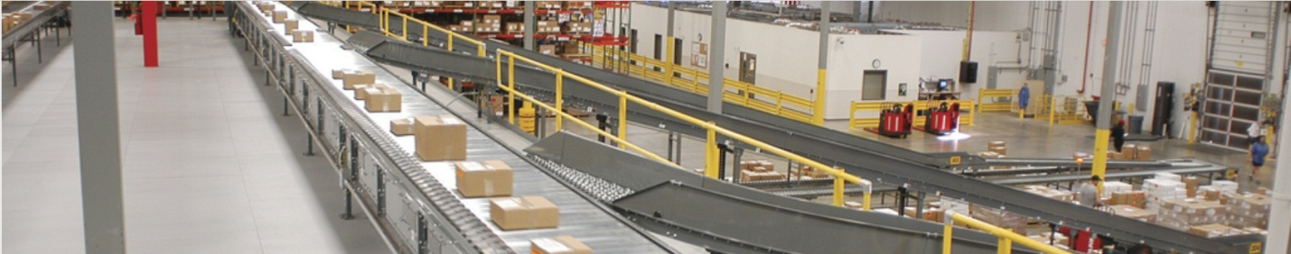
Figure 2-1 Typical Carton Sorter

Posto de trabalho SCP
Os controles Unisort Executado no painel de controle do SCP.
O programa SCP recebe sinais de dispositivos e envia os sinais para acionar dispositivos para controlar a operação física do classificador.
As telas de interface de usuário no SCP permitir que um operador configure o Sorter e monitorar o Carton Sorting.

Control Cabin
The SCP cabinet houses the electronic devices connected to the workstation and the sorter.

Sorter Lane
The sorter consists of a central conveyor for cartons branching off to various lanes that receive the cartons. Each lane is assigned at least 1 store and may include more. A store can be assigned to only 1 lane.

Scanner
A scanner mounted above the conveyor at the beginning of the sorter reads the barcodes on the cartons so the destination lane can be programmed for the carton.

NR/NI Lane
Typically the first lane up the line from the induction station is designated as the NR/NI (No Read/Not Identified) lane. When the sorter cannot determine where to send a carton, it routes it to the NR/NI Lane. For example if the barcode label is not readable or more than 1 barcode is read causing a conflict CSS routes the carton to the NR/NI Lane.

SCP Workstation Startup
Procedures for starting the SCP Workstation must be completed to begin induction operations. A basic knowledge of computers is necessary to start up the system. The exact procedure depends on the state of the system at startup time.

Cold Boot
A Cold Boot is the process of turning a computer on and bringing it up to an operational state when it has been completely turned off.

Start the SCP Workstation
The SCP Workstation receives power from the sorter motor control cabinet so the power to the cabinet must be turned on before starting the workstation.
To start the workstation:
Turn on SCP workstation monitor.
Turn on the SCP workstation. The workstation logs onto CSS and starts all required processes automatically. This may take a few minutes. A special program called Steeplechase VLC must start as the system boots. When booted, the monitor displays a standard Windows Desktop. To verify Steeplechase VLC is running find the Steeplechase VLC Maintainer icon on the desktop and double click on it. The Steeplechase screen is displayed and there should be a status indicator at the bottom right corner of the screen.
All the necessary processes start on the workstation automatically.
Press the Sorter Start Button (green - SSE)

Warm Boot
Warm boot occurs when the CSS applications are stopped or Windows XP restarts.

SCP
To shut down CSS, select the Close CSS Apps icon.
To start CSS, select the Start CSS Apps icon.

CSS Screens
To shut down CSS screens, select File from the Main menu.
Choose Exit from the list of commands to exit CSS.
Select Yes to confirm the exit command. The Windows desktop is displayed
To start CSS screens, select the Start CSS Apps icon.

Windows
To Restart Windows select Start at the lower left corner of the screen.
Choose Shut Down from the list of commands.
Choose Restart from the list of options.
Choose OK to confirm restart.

End of Day
The End of Day process refers only to the workstation. The operator should:
- Verify all cartons are delivered to a lane.
- Press the sorter stop button (SSE)
- Turn power off workstation monitor
Note: It is NOT recommended that you do anything to the workstation.

Beginning of Day
The Beginning of Day process is only for the workstation. The sorter should be stopped. If the “End of Day” process was done correctly, the operator should:
- Turn on the workstation monitor
- Press the Green Sorter Start Button (SSE)
- Select Operations from the Main menu
- Select Sorter Control from the list of commands

Getting Started With CSS
Starting the CSS SCP Workstation displays the CSS Main screen. The CSS Main screen provides real time data related to ongoing sorting operations.
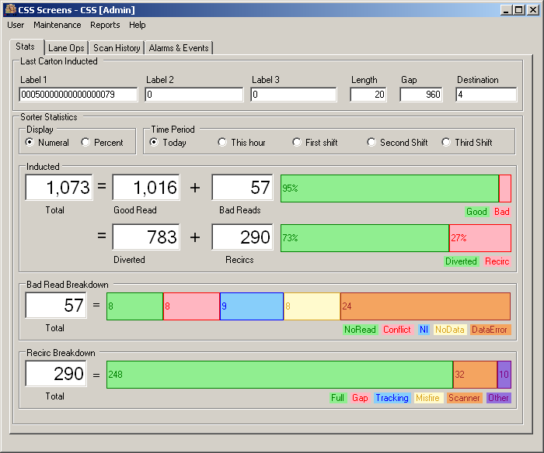
Figure 4-1 CSS Main Screen
The CSS Main screen Stats tab provides statistics related to ongoing sorting operations. The Waves tab displays lane destination assignments for the active Wave. The Reports tab provides a means to configure reports of various statistical data for a specific record period. All screen displays are read-only unless the user logs in with a valid User ID.

User Menu
The User menu provides the means to log on to the CSS Screens application enabling CSS functions based on the Privilege assignment associated with the User ID.
To log onto CSS select User ► Log in from the CSS Main screen menu bar to display the login screen.
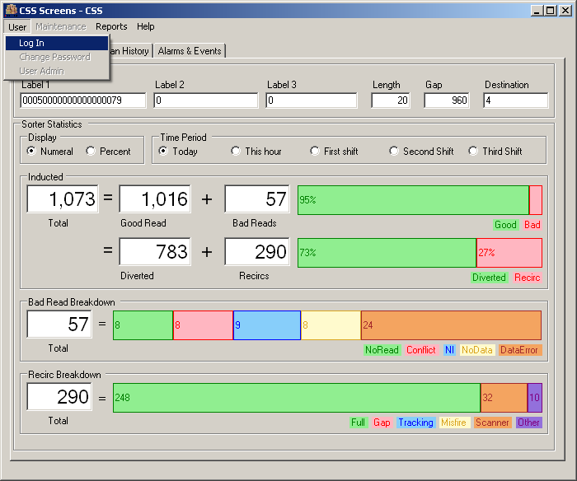
Figure 4-2 CSS User Menu - Log in
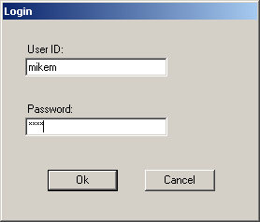
Figure 4-3 CSS Main Screen - Login Screen
To login to CSS enter a valid User ID and Password then choose Ok.
to exit the screen without logging in choose Cancel.
Upon successful login the CSS Main screen remains as the main display.
Login under a User ID with User Administration privilege assignment enables access to the User Admin screen. The User Admin screen enables the user to add, and delete new users assigning them initial passwords. Only users with the Administration privilege assignment can add and delete users from the system.
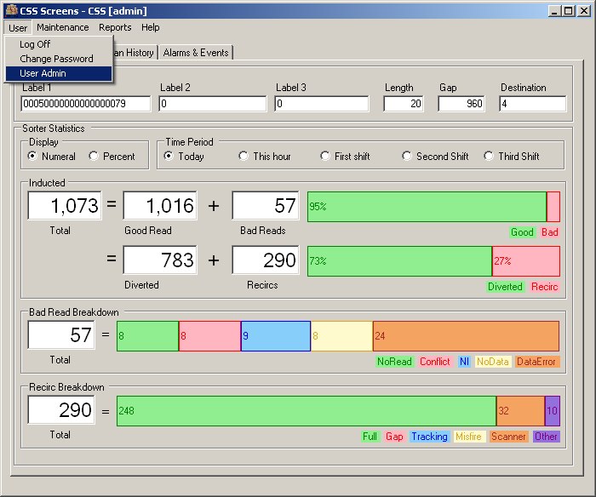
Figure 4-4 User Menu - User Admin
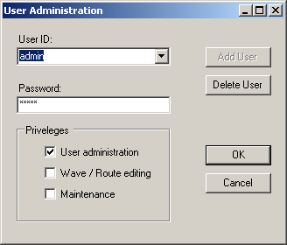
Figure 4-5 User Menu - User Admin
To add a user enter the new User ID and a Password for the new user. Select one or more Privilege assignments for the user then choose OK.
To delete a user select the user from the User ID list box choose Delete User then choose OK.
To change a user's password or privilege assignment select the user from the User ID list box enter a new Password or check different Privilege assignments and choose OK.
Choosing OK returns the user to the CSS Main screen.

Privileges Assignments
CSS Privilege assignments determine the system features a User can access and control.
Privilege Assignment | Description
User Administration | Enables user access to User Admin screen to add, delete and modify User IDs and Privilege Assignments
Wave / Route Editing | Can make changes on the Wave /Route Editing tab
Maintenance | The Maintenance menu is enabled and all Maintenance menu screens and functions are enabled

Users may be assigned one or more privilege assignments. All users can change their own password, start/stop waves and generate reports.

Changing a Password
Each user has privilege to change their own password. To change a password the user must be logged in. Select User ► Change Password from the CSS Main screen menu bar to display the Change Password screen.
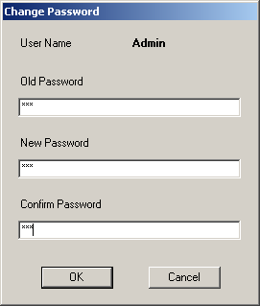
Figure 4-6 Change Password Screen
Enter the Current password, the New password and Re-type the New Password then choose OK.
To exit the Change Password screen without making a change choose Cancel.

CSS Set Up
For full functionality the CSS SCP must be running with the database enabled and the Steeplechase VLC Basesorter program in running mode. Typically this is set to start as the system boots up. The CSS screens application is not required but the screen displays provide real time information related to system operations so the application should be started. If CSS is integrated with a host system or WCS the network must be running and the CSS SCP connection to the network active.

Basic Carton Sorting
To divert a carton to the correct destination lane the CSS SCP Basesorter tracks each carton down the main conveyor from the induction point utilizing input from sensors mounted on the sorter and sends a divert signal to the correct divert actuator at the required time to divert the carton to the correct destination lane.
When a carton passes the induction scanner the barcodes read from the carton are entered into the CSS database. CSS determines if one of the barcodes is a valid Carton ID based on the carton label descriptor configured for the system. Upon validating the Carton ID CSS routes the carton based on the sorting mode configured.
When CSS is integrated with a host system upon validating a Carton ID CSS sends a query to the host for a destination lane. The host receives the query looks up the destination lane for the carton in its database and returns the destination to CSS. CSS then diverts the carton at the destination lane specified.
CSS can be configured to look up the store destination in its own database and route the carton based on a store to lane map managed locally. In this mode the host sends carton routing files to CSS listing cartons and the destination stores that are expected at the sorter. CSS processes the files into a local database and upon identifying a carton at the induction scanner looks up the carton in the local database determining the store destination. CSS then routes the carton to a lane to which the store is assigned based on a store to lane assignment set up locally.
CSS can be configured to route cartons based on data in the barcode label read at the induction scanner. For example if the carton label descriptor requires a Carton ID to be a 12 digit integer with the last four digits representing a Store ID then CSS parses the Store ID from the Carton ID determines the lane to which the store is assigned and sets the destination lane for that carton in the database. Tracking the carton as it travels down the sorter when the carton reaches the correct lane the SCP actuates the divert mechanism and the carton diverts to the destination lane.

CSS Main Screen Stats Tab
The CSS Main screen Stats tab provides continually updating information related to the operation of the sorter. CSS opens to this display by default.
Figure 5-1 CSS Main Screen - Stats Tab
Data displayed on the CSS Main screen Stats tab includes:

Data Field | Description
Last Carton Inducted
Label 1, Label 2 and Label 3 | Values recorded for label barcodes scanned at the induction scanner
Length | Length of the carton in a pre-defined unit of measure
Gap | Length of the gap between the preceding carton and the last carton inducted
Lane | Destination lane assignment for the carton
Sorter Statistics
Select time period | Selection of time period for which the statistics displayed are calculated
Select time period | Today | 24 hour period from the configured start of day
Select time period | This hour | Current one hour period from the top of the hour
Select time period | First shift | Time period based on the first shift configuration
Select time period | Second shift | Time period based on the second shift configuration
Inducted | Number of cartons inducted for the selected
Good Read | Number of cartons for which the scanner read a valid Carton ID  The percentage of total cartons that were Good Reads
Diverted | Number of cartons for which the SCP initiated a divert to a lane  The percentage of total cartons for which the SCP recorded a divert
No Read | Number of cartons for which the scanner failed to read a valid Carton ID  The percentage of total cartons that were No Reads
Total Recirc | Number of times the SCP re-circulated cartons  The percentage of total cartons for which the SCP recorded re-circulations
Recirc Analysis
Tracking | Number of re-circulations caused by tracking errors  Percentage of the total number of cartons processed that re-circulated because of tracking errors
Unknown | Number of re-circulations caused by unknown reasons  Percentage of the total number of cartons processed that re-circulated because of unknown reasons
Gap | Number of re-circulations caused by gap errors  Percentage of the total number of cartons processed that re-circulated because of gap errors
Not assigned | Number of re-circulations caused because a destination lane was not assigned  Percentage of the total number of cartons processed that re-circulated because a destination lane was not assigned
Lane Full | Number of re-circulations caused by a full destination lane  Percentage of the total number of cartons processed that re-circulated because of a full destination lane
Lane Disabled | Number of re-circulations caused by a disabled destination lane  Percentage of the total number of cartons processed that re-circulated because of a disabled destination lane
Misfire | Number of re-circulations caused by a divert failure  Percentage of the total number of cartons processed that re-circulated because of a divert failure
Scanner error | Number of re-circulations caused by a scanner error  Percentage of the total number of cartons processed that re-circulated because of a scanner error

CSS Main Screen Waves Tab
The CSS Main screen Wave Control tab enables the user to set up Destinations, Stores, Waves and Routes.
Select the Waves Control tab on the CSS Main screen to access Wave Control functions.
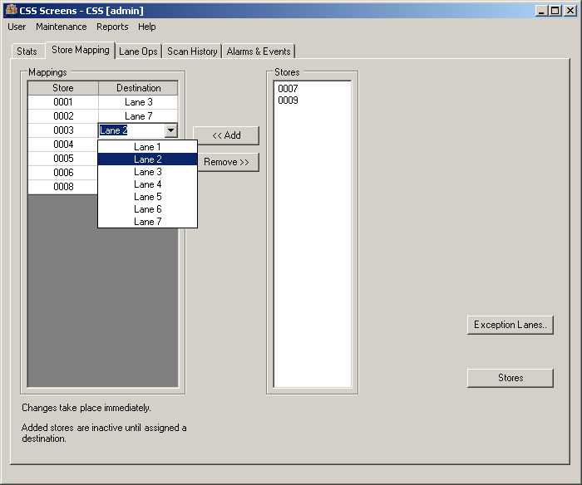
Figure 5-2 CSS Main Screen - Waves Tab
CSS defines a Destination as a designation for the physical conveyor path from the sorter main conveyor to the destination conveyors to which cartons are routed.
CSS defines a Store as an alphanumeric designation for the destination addresses to which cartons must be shipped. (For retail distribution centers this is typically the stores to which they ship merchandise but logically it could be other distribution centers or warehouse locations).
CSS defines a Route as a single Store or group of Stores that can be assigned to a Wave.
CSS defines a Wave as a preset assignment of Routes to Destinations.
The CSS Wave Control tab on the CSS Main screen displays a list of the Available Waves. The Destination assignments for the active Wave display next to the list of Waves. If no Wave is active this field remains blank.
To start a Wave select a Wave from the list of Available Waves and choose Start. The Wave starts, Destination assignments for the Wave display and the Start button changes to a Stop button. Only one Wave can be active at a time so to Start a new Wave the active Wave must be stopped.
When configured for Store to Lane Mapping instead of a Wave Control tab on the CSS Main screen there is a Store Mapping tab.

Sorter Destinations
CSS Destinations are designations for the physical lanes on the sorter. The lanes are typically numbered in sequence with some lanes having special assignments such as No Read or Recirc and the rest assigned to shipping destinations (Routes).
To manage sorter destinations select the Wave Control tab on the CSS Main screen and choose Destinations.
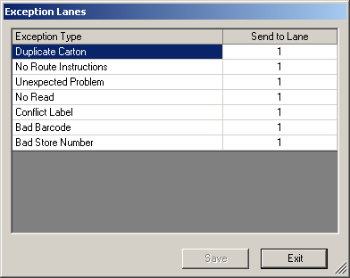
Figure 5-3 CSS Lane Editor Screen
Each physical lane on the sorter must have a logical Destination ID assignment. The Description assigned is optional.
To designate a destination for a special purpose such as No Information, No Read, Label Conflict, or Invalid Label choose the lane from the list box next to the indicated special purpose.
CSS routes cartons to special purpose lanes when it is unable to determine a shipping destination lane based on the input from the Induction scanner.
Special Purpose Lane assignments include:

Special Purpose Lane | Description
No Information | CSS does not find the Carton ID in the database
No Read | The Induction scanner cannot read a barcode on the carton
Label Conflict | CSS has detected the same Carton ID previously
Invalid Label | The label value input from the scanner does not conform to the label descriptor configured for the database

In most cases a single lane is designated for special purpose handling.

Stores
CSS Stores represent the destinations to which a warehouse or distribution center ships. CSS maintains a record for each store destination. To edit the stores in the system choose Stores… to open the Stores screen.
Enter the appropriate Name, Description and address information for the store.
MaxCartons a feature associated with Waves, indicates the maximum number of cartons that divert to a store for a Wave. If set to zero all cartons divert. If set greater than zero the specified number of cartons divert then additional cartons re-circulate.
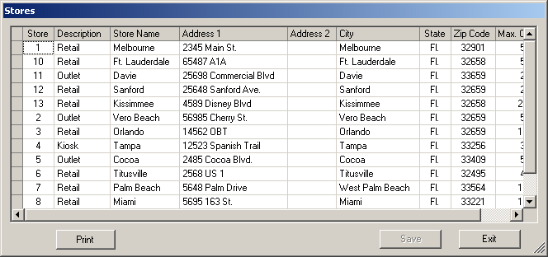
Figure 5-4 CSS Stores Screen
To add a Store place the cursor at the blank record at the bottom of the data grid and enter the appropriate information. Then choose Save.
To print the Stores list choose Print. (The computer running the CSS Screens application must be connected to a network printer for this function to work.)
To exit the Stores screen choose Exit.

Routes
Since a Wave maps Routes to sorter lanes the Routes must be configured before the Wave can be configured. A Route may represent a single shipping destination (Store) or a group of shipping destinations (Stores). Shipping destinations may or may not be grouped together for many different reasons. A route might represent a single store destination because of the volume of cartons shipped to the store requires an exclusive run. A Route might group stores together to make loading of trailers more efficient, because they are in geographic proximity, because they require a common carrier or because it is less expensive to ship them together.
To create and delete routes select the Waves tab on the CSS Main screen and choose Route Builder to open the Route Builder screen.
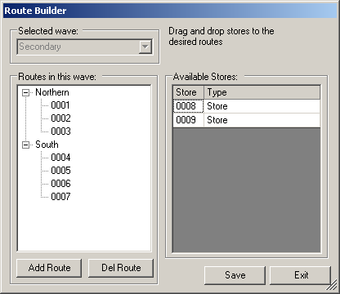
Figure 5-5 Route Builder Screen
The Route Builder screen displays Routes and Stores lists. Click on the + or - icon to expand the Route tree and view the Stores assigned to the listed Routes.
To create a new route choose New route to open the New Route screen.
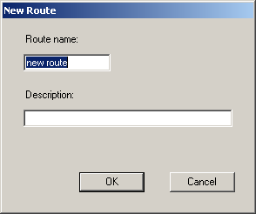
Figure 5-6 New Route Screen
Enter a Route name and Description then choose OK.
To exit the New Route screen without making changes choose Cancel.
Upon creating a new Route assign stores to the route by dragging the Store from the Stores list and dropping it on the Route. You cannot assign Stores to more than one Route. Once assigned to a Route the Store ID text color changes to gray.
To save the changes made in the Route Builder screen choose Save.
To exit the Route Builder screen choose Exit.

Waves
A Wave is a mapping of Routes to lanes on a sorter. By starting and stopping Waves a new set of Routes can be assigned to the sorter lanes quickly and efficiently. Many Waves can be configured in the database but only one Wave at a time can be active on the sorter.
To create and delete Waves select the Waves tab on the CSS Main screen and choose Wave Builder to open the Wave Builder screen.
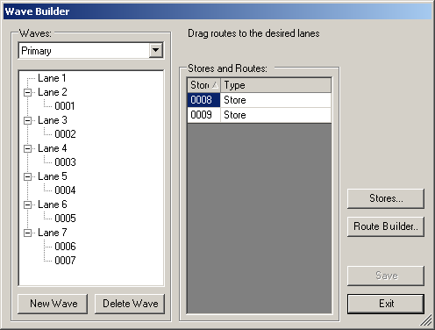
Figure 5-7 Wave Builder Screen
The Wave Builder screen displays Waves and Routes lists. Click on the + or - icon to expand the Wave tree and view the Routes assigned to the listed Waves.
To create a new Wave choose New wave to open the New Wave screen.
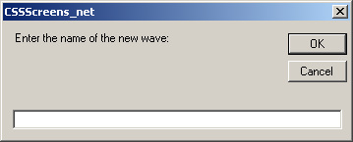
Figure 5-8 New Wave Screen
Enter a Wave name then choose OK.
To exit the New Wave screen without making changes choose Cancel.
Upon creating a new Wave assign Routes to the Wave by dragging the Route from the Available Routes list and dropping it on the Wave. You cannot assign Routes to more than one Wave. Once assigned to a Wave the Route ID text color changes to gray.
To save the changes made in the Wave Builder screen choose Save.
To exit the Wave Builder screen choose Exit.

CSS Main Screen Store Mapping Tab
The Store Mapping tab enables the user to select stores from a list of stores configured for the system and add them to a Destination Mapping. Stores and Destinations must be entered using the Stores and Lane Editor screens.
Figure 5-9 CSS Main Screen - Store Map Tab
To add a store to the Mapping select the store from the list of stores and choose <<Add. The selected store moves from the Stores list to the Mappings list.
To remove a store to the Mapping select the store from the list in Mappings and choose Remove>>. The selected store moves from the Mappings list to the Stores list.
To choose a destination for a store in the Mappings list click on the Destination column on the row of the Store you wish to assign. A list of the available configured destinations displays.
Choose the destination from the list and the assignment takes effect immediately.
To access the Lane Editor screen choose Destinations.
To access the Stores screen choose Stores.

CSS Main Screen Reports Tab
CSS generates certain pre-configured statistical reports for operations within a specified time frame. The reports collect the statistics displayed on the CSS Main screen Stats tab for the time frame specified except the Lane Stats report which collects data related to the sorter lanes.
To generate reports select the Reports tab on the CSS Main screen to access Reports functions.
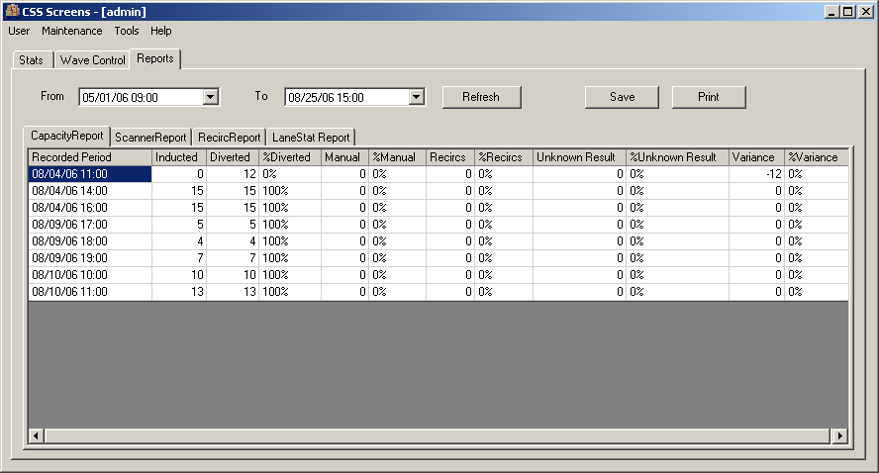
Figure 5-10 CSS Main Screen - Reports Tab
To configure a report select the desired report tab, define a time frame by selecting a date and time in both From and To then choose Refresh.
To save the report as a Microsoft Excel spreadsheet file choose Save….
to print the report choose Print….
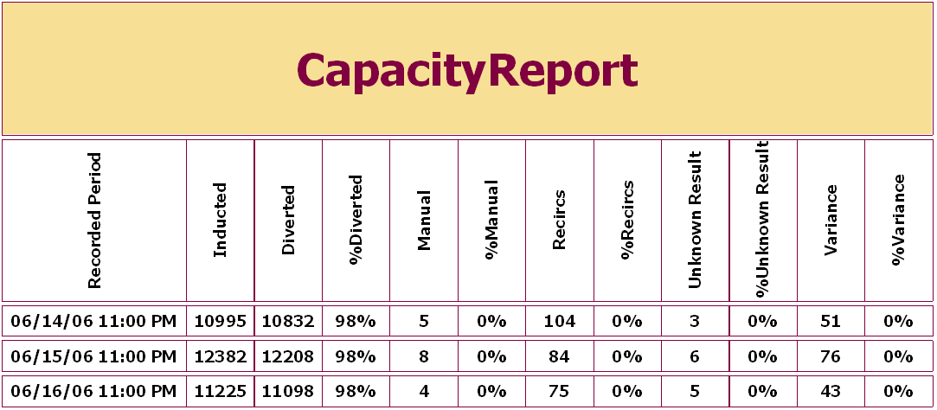
Figure 5-11 CSS Capacity Report
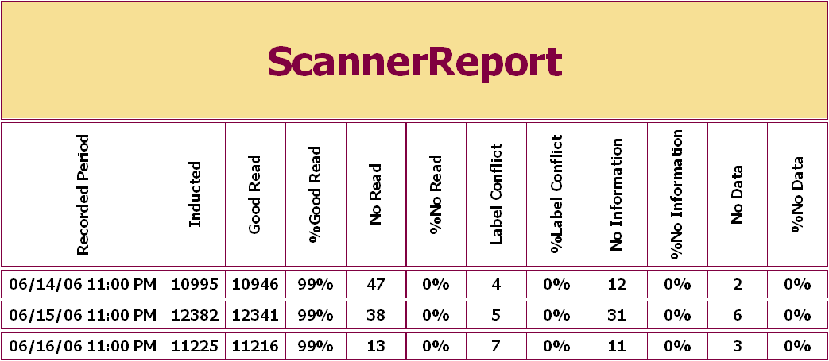
Figure 5-12 CSS Scanner Report
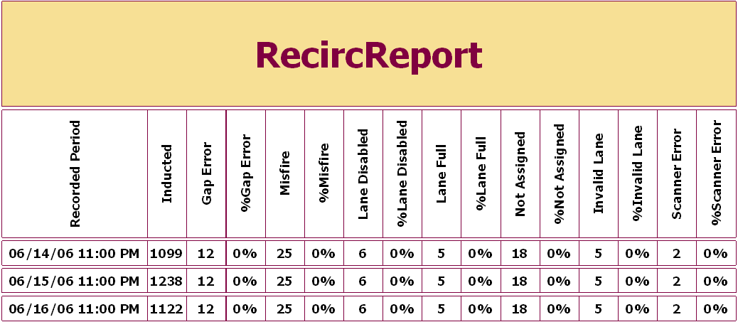
Figure 5-13 CSS Recirc Report
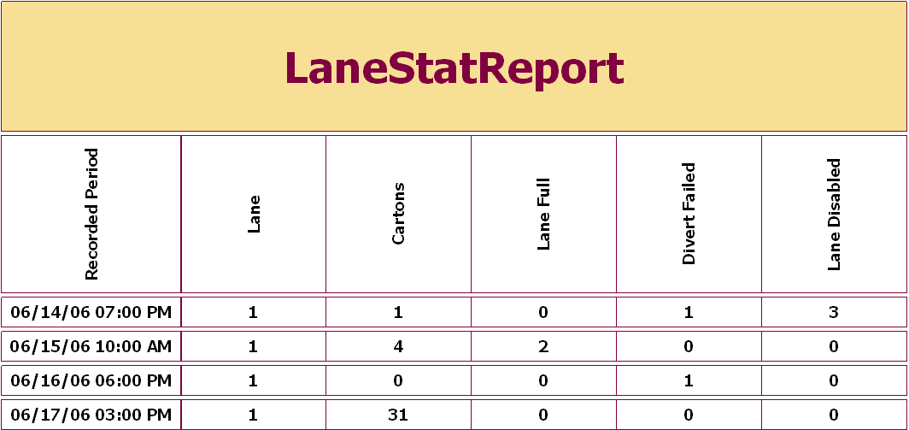
Figure 5-14 CSS Lane Stats Report

CSS Main Screen Alarms and Events Tab
The CSS Alarms and Events Tab displays information related to the 50 most recent events occurring with the system. There are many types of events the system records and the events can be filtered by Event Type to limit the list when searching for an event.
Events provide a valuable diagnostic tool to determine why the system may have erred.
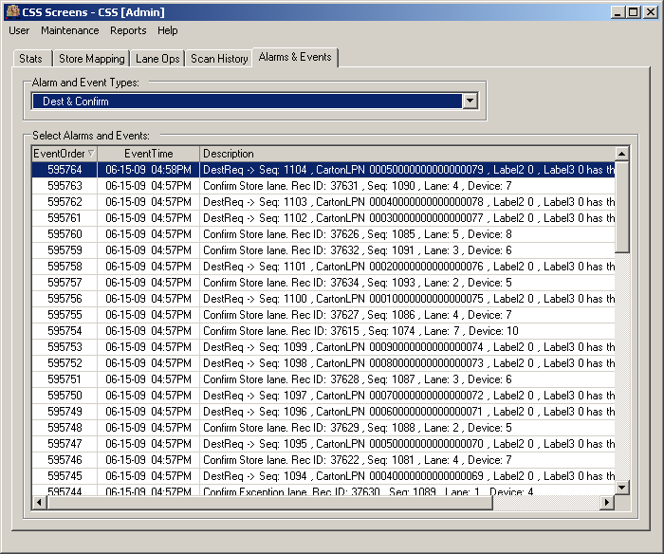
Figure 5-15 CSS Main Screen Alarms and Events Tab
Alarms and events default to display All Event Types.
To filter the event list by Event Type select an Event Type in Alarm and Event Types. Based on the selection Selected Alarms and Events updates immediately and displays the associated data.
Event Types include:

Data Field |  | Description
Sorter | Events related to the physical state of the sorter
Sorter | Start/Stop |  | Sorter start and stop events
Sorter | Gapping |  | Sorter events related to the gapping function
Sorter | Scanner |  | Sorter events related to the scanner function
Sorter | Weight |  | Sorter events related to the scale if present
Sorter | Destination/Confirmation |  | Sorter events indicating destination assignments and divert confirmations
Sorter | Tracking |  | Sorter events related to the tracking errors
Sorter | Lane Full |  | Sorter events related to the Lane Full conditions
Sorter | Re-circulation |  | Sorter events related to carton re-circulation
System | Events related to system operation
System | All zones Start/Stop |  | Events related to sorter plus infeed and outfeed conveyors stopping or starting
System | Jams |  | Events related to carton jams

CSS Maintenance Windows Event Log
Since the CSS SCP Service application runs as a Windows Service CSS provides a means to directly view the Windows Events related to the SCP Service. To view the Windows event log select Maintenance ► Event Log - Sorter from the CSS Main screen menu bar to open the System Event Log Viewer screen.
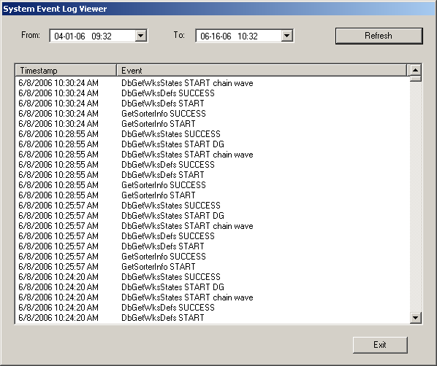
Figure 5-16 View Event Log Screen
To view events select the desired date and time to start and end the list of events in From and To then choose Refresh. The list displays the time of the event and a description of the event.
To exit the System Event Log Viewer screen, choose Exit.

Problem Determination and Resolution
This section provides tips for to assist the operator when the sorter does not operate in a “normal” manner. It is understood that “normal” differs from individual to individual and from site to site. This section deals with general sorter operations.
The following areas are addressed:
- Sorter Starting
- General Sorter Operation
- Carton Sorter Operation

Starting the Sorter
Should the sorter fail to start, follow the steps below.
Step # | Operation | Yes – Action | No – Action
 | Press Start Button (SSE) | Sorter should Spin – Done | Proceed to the next step
 | Check All E-Stops and reset | Press Start Button (SSE) | Proceed to the next step
 | Is induction screen on? | Proceed to the next step | Start Induction application
 | Did Screen come out of sleep mode? | Proceed to the next step | Reboot system
 | Is workstation power off? | Turn workstation on. | Call SDI support
 | Do Gap belts spin? | Proceed to the next step | No air – call maintenance
 | Sorter starts but stops after 5 seconds | Check for jam carton on sorter

General Sorter Operation
Question: | When pressing the start button, the horn does not sound
Answer: | - The horn may be broken – call maintenance  - The horn volume may have been turned down. This is a violation of OSHA and must be fixed immediately – call maintenance  - Steeplechase VLC is not running  - SCP applications are not running
Question: | When pressing the start button the horn sounds, but the sorter does not turn.
Answer: | - The motor bypass switch may be turned off. Stop the sorter and call maintenance  - Power problem in SCP cabinet – call maintenance  - The sorter may be jammed – press the stop button and call maintenance  - Inverter overload
Question: | When pressing the start button the horn sounds, the sorter starts but shuts off in about 5 seconds.
Answer: | - There is a jam on the sorter. Press the E-STOP button and investigate. The jam must be cleared before sortation can restart. Maintenance should be called to inspect the sorter for damage. If any damage has occurred, DO NOT use the sorter and call SDI for assistance.  - The encoder or timing device is slipping or defective giving a false jam condition. Call maintenance.  - Certain lanes can be configured to stop when sorter when they are full like recirculation.

Carton Sorter Operation
Question: | Gap belts do not turn.
Answer: | - The Gap Belts are run by air. If air pressure is too low, the belts will not turn and sorter will not run.
Question: | Cartons Re-circulate on the sorter constantly.
Answer: | - Destination Lane is full  - Barcode label is not readable  - Multiple barcode labels have been read on carton.
Question: | Items are dropping at NI
Answer: | - Barcode is invalid or more than 1 exists

Table of Figures
Figure 2-1 Typical Carton Sorter 3
Figure 4-1 CSS Main Screen 6
Figure 4-2 CSS User Menu - Log in 7
Figure 4-3 CSS Main Screen - Login Screen 7
Figure 4-4 User Menu - User Admin 8
Figure 4-5 User Menu - User Admin 9
Figure 4-6 Change Password Screen 10
Figure 5-1 CSS Main Screen - Stats Tab 12
Figure 5-2 CSS Main Screen - Waves Tab 14
Figure 5-3 CSS Lane Editor Screen 15
Figure 5-4 CSS Stores Screen 16
Figure 5-5 Route Builder Screen 17
Figure 5-6 New Route Screen 17
Figure 5-7 Wave Builder Screen 18
Figure 5-8 New Wave Screen 18
Figure 5-9 CSS Main Screen - Store Map Tab 19
Figure 5-10 CSS Main Screen - Reports Tab 20
Figure 5-11 CSS Capacity Report 21
Figure 5-12 CSS Scanner Report 21
Figure 5-13 CSS Recirc Report 22
Figure 5-14 CSS Lane Stats Report 22
Figure 5-15 CSS Main Screen Alarms and Events Tab 23
Figure 5-16 View Event Log Screen 25

