CSS

Maint User Manual

SDI Industries - 1819 Riverview Drive - Melbourne Florida - 32901

4/13/2012

COPYRIGHT NOTICE
Copyright © 2012 SDI Industries, Inc.
All Rights Reserved
NOTICE
THIS DOCUMENT BELONGS TO SDI INDUSTRIES, INC. IT IS CONSIDERED A TRADE SECRET AND IS NOT TO BE DIVULGED OR USED BY PARTIES WHO HAVE NOT RECEIVED WRITTEN AUTHORIZATION FROM SDI INDUSTRIES, INC.

Table of Contents
1 Introduction 1
2 Conveyor Setup Procedure 3
2.1 Set up I/O layout – Station, slot, point 3
2.2 Add Zones 7
2.3 Add Inverter Details 8
2.4 Add Motors 10
2.5 Add Control Stations (start/stop stations) 11
2.6 Add Horns 13
2.7 Add Stack Lights 15
2.8 Layout the Zones 16
2.9 Add Flow Controls 17
2.10 Add Traffic Cops 18
2.11 Add Motor Dependent Outputs 19
2.12 Add Output Dependent Outputs 20
2.13 Add Oilers 21
2.14 Add Jam Devices 22
2.15 Assign Energy Management Services To Motors 23
2.16 Set Up Merges 24
2.17 Set Up Gappers 25
3 Sorter Setup Procedure 26
3.1 Set up ZMC 26
3.2 Add Encoders 26
3.3 Add Scanners 27
3.4 Add Production Rate Devices 28
3.5 Add Sorters 29
3.6 Setup the Sorters 30
3.7 Set Up The Lanes 31
3.8 Set Up The Lane Full Devices 32
3.9 Set Up The Lane Inhibit Devices 33
3.10 Setup The Shoe Diverters 34
3.11 Add Racetrack Mode 35

Introduction
This document provides instruction in the use of the CSS conveyor setup program “CSS Maint.exe.”
CSS Conveyor Control operates from a PC referred to as the System Control Processor (SCP). The PC includes a software package called Steeplechase VLC that enables design of the control logic and runtime machine control operations. SDI has a custom designed conveyor control project that runs within the VLC environment called the Basesorter.
The Basesorter communicates with control devices installed on the conveyor system using a scanner card installed on the SCP that enables the SCP to be wired to the control circuits. The SCP may also have one or more network communication cards installed as well.
The Basesorter communicates with the CSS database using a Windows Service called SCPService.
The SCP Basesorter, SCPService and the CSS database must all be operational for the system to function.
SDI designed a Windows application called “CSS Maint.exe” to configure the Basesorter and the CSS database with essential data to enable programed conveyor control.
The CSS database includes a table, DownloadConfig that maintains all configuration data for the VLC and downloads this data to the VLC runtime program each time the VLC boots.
To set up conveyor control, a CSS database must be installed on the database server. This server can be the same PC on which the VLC runs, but more often it is a separate server.
The standard server file configuration for CSS places all needed files in the directory path;
D:\CSS\runtime\
The database file is stored in the folder D:\CSS\runtime\database.
The executable files are installed in the directory path; D:\CSS\runtime\exe. CSS Maint.exe is installed in this folder.
CSS Maint.exe has a configuration file in the same folder that connects the application to the database. The configuration file can be edited in Windows Notepad to point the application to the correct database.
CSS Maint Configuration file:
<?xml version="1.0" encoding="utf-8"?>
<configuration>
<appSettings>
<!-- User application and configured property settings go here.-->
<!-- Example: <appSetting key="settingName" value="settingValue"/> -->
<appSetting key="Domain" value="RTI_SORTER" />
<appSetting key="Server" value="." />
<appSetting key="Database" value="CSS" />
<appSetting key="SCPID" value="1" />
<appSetting key="CB_UseZMC" value="0" />
<appSetting key="CB_UseGapper" value="0" />
<appSetting key="CB_UseMerge" value="0" />
<appSetting key="CB_UseRunSteps" value="0" />
<appSetting key="VLCName" value="" />
<appSetting key="TouchScreen" value="0" />
<appSetting key="DBUser" value="sa" />
<appSetting key="DBPwd" value="rti" />
</appSettings>
</configuration>
You must enter the correct domain name, server node name or IP address, database name, DBUser and DBPwd for the application to access the database. Entering a period in the Server value field indicates the server is the local machine.

Conveyor Setup Procedure
Each setup consists of building smaller pieces into larger pieces. For example you need a zone to put a motor into, you need I/O points to assign to a motor, etc. This hierarchy mandates dependencies.
Order of object creation for ZMC – all software is in reference to the CSS_Maint.exe tool
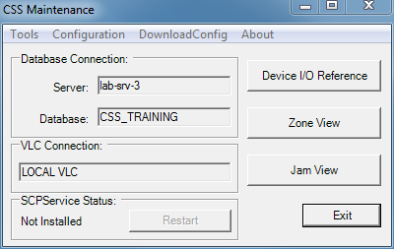
Figure 1 CSS Maint.exe Main Screen

Set up I/O layout – Station, slot, point
Use menu Configuration ► IO Network
Click the Device I/O Reference button
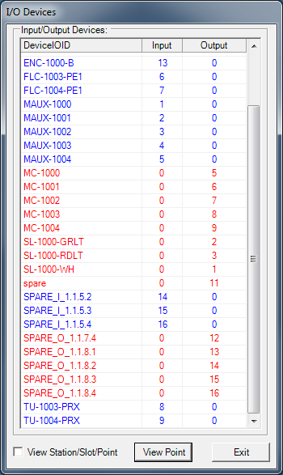
Figure 2 Device I/O Reference
You may edit any point the begins with the word “Spare”
To rename a point that has already been named, highlight the point and press ALT+E
Enter a device I/O reference for each control device following the SDI control device naming standard.
Controls Naming Conventions

Check View Station/Slot/Point to display the I/O reference for the device.
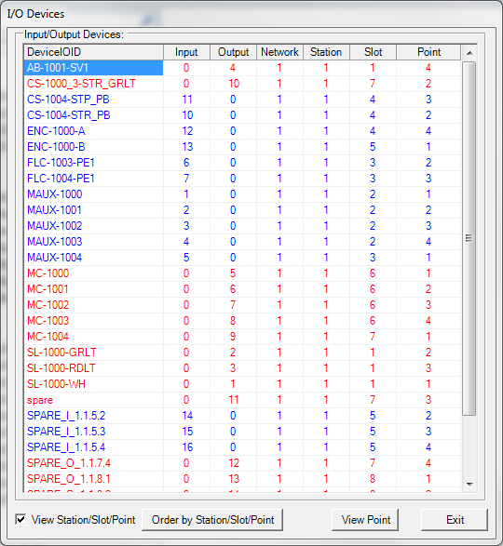
Figure 3 Device I/O Reference

Input and Output IDs must be unique. Each device reference includes:

Device Reference | Description
Input | Identifying number for the input terminal
Output | Identifying number for the output terminal
Network | Identifying number for the Network on which the I/O resides
Station | Identifying number for the remote enclosure where the device is wired
Slot | Position in the remote enclosure of the I/O terminal
Point | Number of the point on the terminal to which the device is wired.

Select Order by Station/Slot/Point to put the list in numerical order by reference number.
Select View Point to open up the I/O Point set up screen.
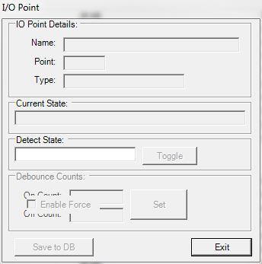
Figure 4 I/Point Setup
I/O Point Details include:

I/O Point Setting | Description
Name | Identifying string assigned to point
Point | Number of point
Type | I or O for Input or Output
Station | Remote station where point is located
Current State | State of the point as of this viewing
Detect State | High (1) or Low (0) indicates the whether voltage signals the device is on or off
Debounce Counts | Indicates the number of scan cycles before the detect state is implemented
On Count | Debounce delay at the beginning of the signal
Off Count | Debounce delay at the end of the signal

Choose Set to set the Debounce Counts entered.
Choose Save to DB to save the data to the DeviceIOConfig table in the CSS database.
Choose Exit to close the dialog screen.
Choose Exit to close the Device I/O Reference screen.

Add Zones
Use Configuration►ZMC►Zones
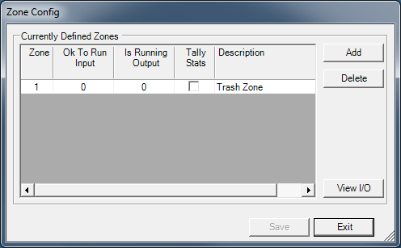
Figure 5 Zone Config
Choose Add to add a zone.
Enter a unique zone number.
If the zone needs an interlock to control whether it is allowed to start, enter the controlling input point in the OK to Run Input box. The zone will not be allowed to run until this input is Latched. If no interlock is required, leave this set to 0.
If you want to set an output ON when the zone is running, enter the output in the Is Running Output box. Leave this set to 0 if you don’t need this function.
Check Tally Stats to set the database to track statistics on the zone. Statistics captured are the start/stop times and jams.
Enter a Description to indicate what the zone does. This description will be used in the Eventlog to describe events pertaining to the zone.
Choose Exit to close the Zone Config screen.

Add Inverter Details
Inverters are simply motors that have much more control. For example, a servo would have an entry as a motor that would define the very basics of control, but then it would have an entry to an inverter that would define the extra necessary control information needed. Servo’s need a speed reference, some need a forward or reverse signal, some have a fault indicator. All these extra parameters would be defined in the inverter parameters.
Most motors do not have, nor need, an inverter entry.
Use Configuration►ZMC►Inverters
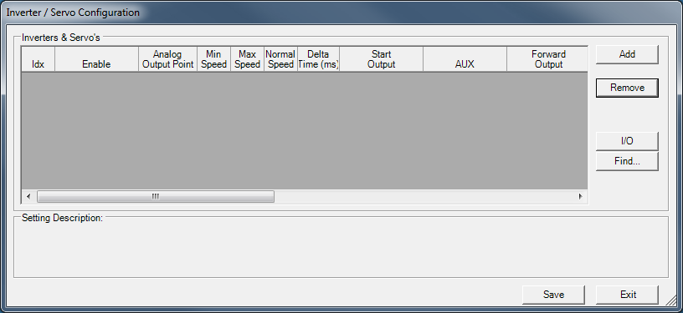
Figure 6 Inverter/Servo Configuration
Choose Add to add an inverter configuration. The program adds them in Idx sequence.
Configuration settings include:

Inverter/Servo Setting | Description
Idx | Sequence number identifying a configured inverter. These must be sequential.
Enable | An inverter or servo is normally Enabled via the assigned motor’s output point and turns ON or OFF immediately on a start or stop. If you require that the servo/VFD ramp down before turning the Enable OFF then assign the Enable here instead. Example, servo’s do not automatically ramp down when the Enable is OFF, forcing the servo to slam to a stop. The Enable point is turned off AFTER the servo has ramped down.
Analog Output Point | The analog point number used for a speed reference to the VFD or servo. If unused leave at 0
Min Speed | If using an analog speed reference, this setting is the minimum value used (normally 0)
Max Speed | If using an analog speed reference, this setting is the maximum value used Some analog modules have a max at 128, some use 256.
Normal Speed | If using an analog speed reference, this setting is the normal speed setting
Delta Time (ms) | The amount of time in which to make analog speed changes. Only used of analog speed references are used. Specified in milliseconds.
Start Output | The output to set to make the motor run. Typically for VFDs that use both Start and Stop points. When the motor is started Start Output will be set ON and Stop Output will be set OFF.
AUX | The output that signifies the motor is running. Normally this setting should be set at the motor level.
Forward Output | The output to set to make the motor run forward. Typically for VFDs that use both Forward and Reverse signals.
Reverse Output | The output to set to make the motor run in reverse. Typically for VFDs that use both Forward and Reverse signals. In this version this output is always set OFF and there is no default way to run the motor in reverse without customzing.
Output Ref A | VFDs only: Speed Ref A/B/C are outputs to an inverter that specify a speed reference depending on the configuration of the VFD. The VLC will turn any defined Speed Ref high when a motor is started. Therefore if you need a Ref point to remain low on startup, omit it in this configuration.
Output Ref B | VFDs only: Speed Ref A/B/C are outputs to an inverter that specify a speed reference depending on the configuration of the VFD. The VLC will turn any defined Speed Ref high when a motor is started. Therefore if you need a Ref point to remain low on startup, omit it in this configuration.
Output Ref C | VFDs only: Speed Ref A/B/C are outputs to an inverter that specify a speed reference depending on the configuration of the VFD. The VLC will turn any defined Speed Ref high when a motor is started. Therefore if you need a Ref point to remain low on startup, omit it in this configuration.
Stop Output | The output to set to make the motor stop. Typically for VFDs that use both Start and Stop points. When the motor is started Start Output will be set OFF and Stop Output will be set ON.
Fault Input | The input that signals the VFD or servo has faulted
Fault Reset | The output to set to clear a VFD or servo fault.
Description | Text describing the inverter’s purpose.

Choose Save to commit the settings to the database InverterDetail table.
Choose Exit to close the Inverter/servo Configuration screen.

Add Motors
Use Configuration►ZMC►Motors
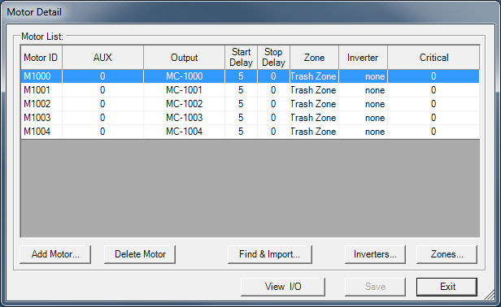
Figure 7 Motor Detail
Select Add to open the Add New Motor dialog box and add a motor detail. Enter the Motor ID and choose OK.
Choose Cancel to end the process.
To delete a Motor Detail, select it from the Motor List and choose Delete Motor.
To find a motor choose Find and Import to open the motor search dialog box. Enter the search criteria and choose OK to start the search. This will search the I/O device list for the standard SDI prefix for motor I/O and import that data to the Motor Detail.
To configure an inverter to control the motor, select Inverters to open the Inverter/Servo Configuration screen.
To assign the motor to a Zone choose Zones to open the Zone Interlocks screen. You may also assign the motors to zones using the Zone Layout tool as described later.
Choose View I/O to view the list of I/O devices.
Data to enter for each motor includes:

Motor Detail | Description
Motor ID | Unique character string identifying the motor (See Controls Naming Conventions)
AUX | Indicates if there is an auxiliary input from the motor to indicate it is running.  0 indicates the motor is running when the output is on.
Output | I/O device ID
Start Delay | Scan cycle delay before turning on the motor output.
Stop Delay | Scan cycle delay before turning off the motor output.
Zone | Control zone to which the motor is assigned.
Inverter | ID of inverter
Critical | When set, this will include the motor in the group of motors to determine if the zone is running. All critical motors must be running before the zone is considered running.

Optional – assign motors to zones. This will also be done later in step 2.8.
Choose Save to commit the settings to the MotorDetail table in the database.
Choose Exit to exit the Motor Detail screen.

Add Control Stations (start/stop stations)
Use Configuration►ZMC►Control Stations
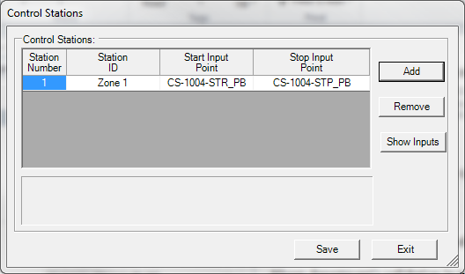
Figure 8 Control Stations
Control Stations house push buttons switches that turn zones of conveyor on or off.
Choose Add to open the Add a New Control Station dialog box and enter a new control station.
Enter a Station ID and choose OK. The station ID will be used to assign the whole control station to a zone.
Choose Cancel to end the process.
Select a Control Station and choose Remove to remove it from the list.
Select Show Inputs to display a list of inputs. You can drag the appropriate input to the Start Input Point and Stop Input point fields to configure the control station.
Setting for control stations include:

Control Station Detail | Description
Station Number | Sequence number of control station
Station ID | Name of control station
Start Input Point | I/O Device ID that turns on when the Start button is pushed
Stop Input Point | I/O Device ID that turns on when the Stop button is pushed

Choose Save to commit the settings to the StartStopConfig table in the CSS database.
Choose Exit to exit the Control Stations screen.

Add Horns
Use Configuration►ZMC►Horns
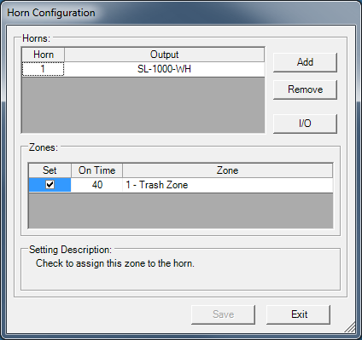
Figure 9 Horn Configuration
Horns sound as a warning when zones start.
Choose Add to add a new horn output.
Select a Horn and choose Remove to remove it from the list.
Select I/O to display a the list of I/O devices. You can drag the output for the horn to the Output field in the Horns list.
Setting for Horns include:

Control Station Detail | Description
Horn | Sequence number of horn
Output | Output that controls the horn
Zones
Set | Check to set the horn to work
On Time | The amount of time the horn stays on when the zone starts
Zone | Zone to which the horn is assigned

Choose Save to commit the settings to the HornConfig table in the CSS database.
Choose Exit to exit the Horns screen.

Add Stack Lights
Use Configuration►ZMC►Lights
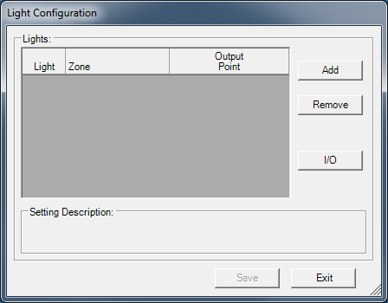
Figure 10 Configure Lights
Assign lights to zones as required

Layout the Zones
Use Configuration►ZMC►Zone Layout
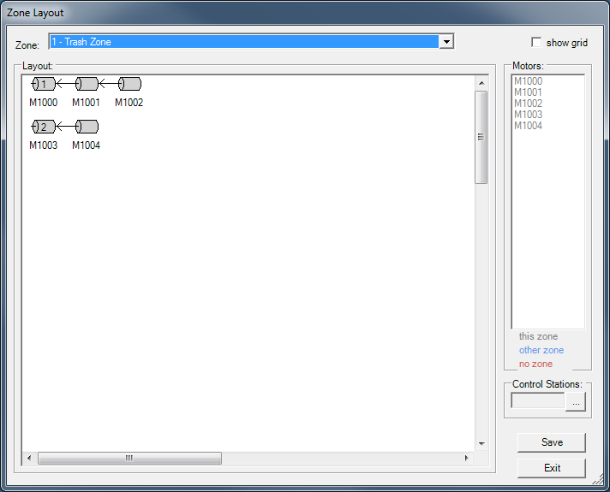
Figure 11 Zone Layout
Drag-n-drop motors into the various zones
Create parent-child relationships between motors as required.
Right click the motor.
Select “Link to Parent”.
Each parent motor should have a unique startup number (the little number displayed inside the motor).
Right click the motor.
Select “set startup number”.
Assign control stations to zones as required.

Add Flow Controls
Use Configuration►ZMC►Flow Control
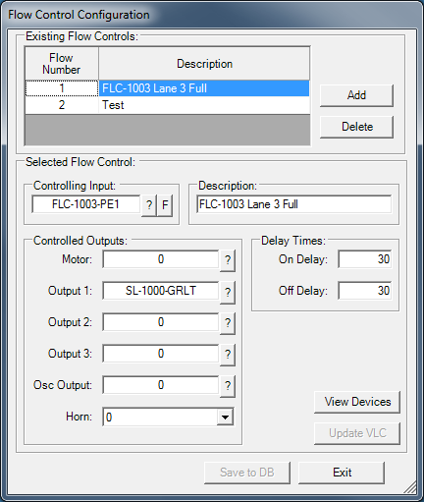
Figure 12 Configure Flow Control

Add Traffic Cops
Use Configuration►ZMC►Traffic Cops
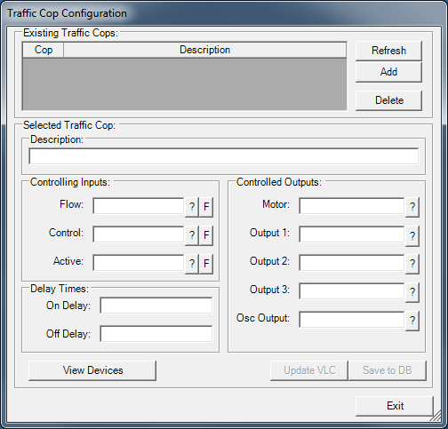
Figure 13 Configure Traffic Cops

Add Motor Dependent Outputs
Use Configuration►ZMC►Motor Dependent Outputs
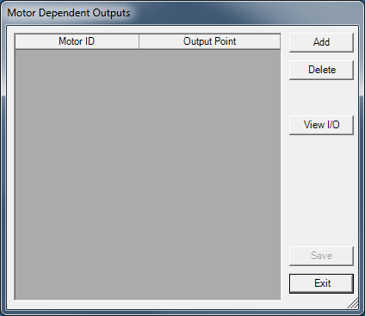
Figure 14 Configure Motor Dependent Outputs

Add Output Dependent Outputs
Use Configuration►ZMC►Output Dependent Outputs
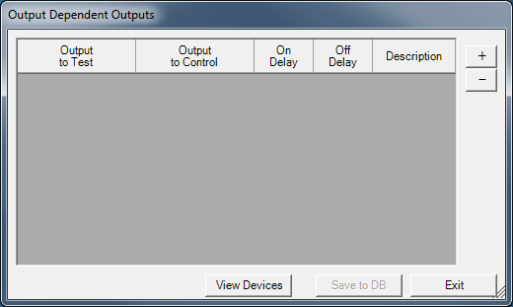
Figure 15 Configure Output Dependent Outputs

Add Oilers
Use Configuration►ZMC►Oilers
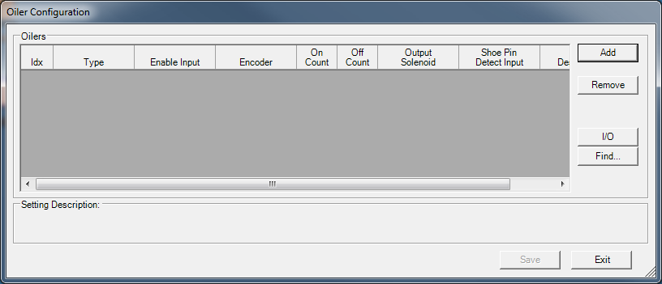
Figure 16 Configure Oilers

Add Jam Devices
Use Configuration►ZMC►Jam Devices
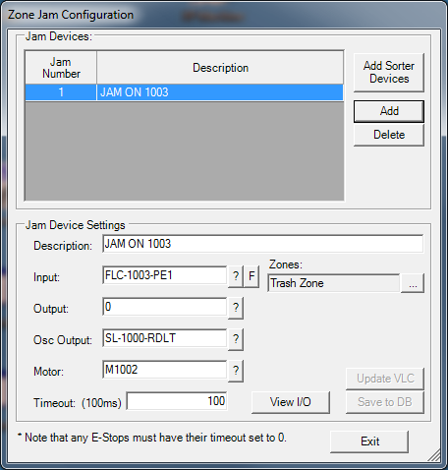
Figure 17 Configure Jam Devices

Assign Energy Management Services To Motors
Use Configuration►ZMC►EMS
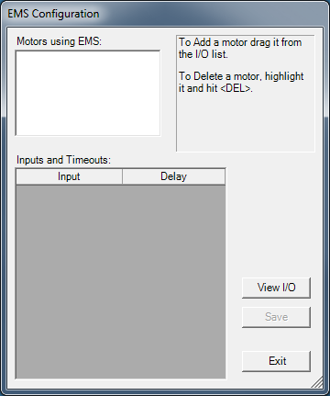
Figure 18 Configure Energy Management Services

Set Up Merges
Use Configuration►Merge …
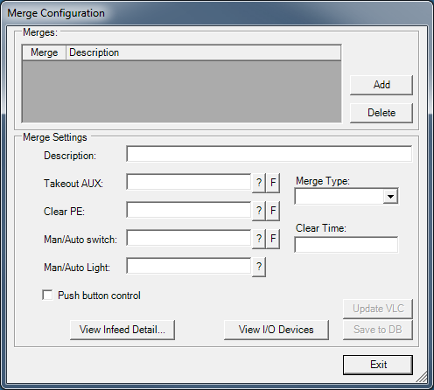
Figure 19 Configure Merges

Set Up Gappers
Use Configuration►Gapping
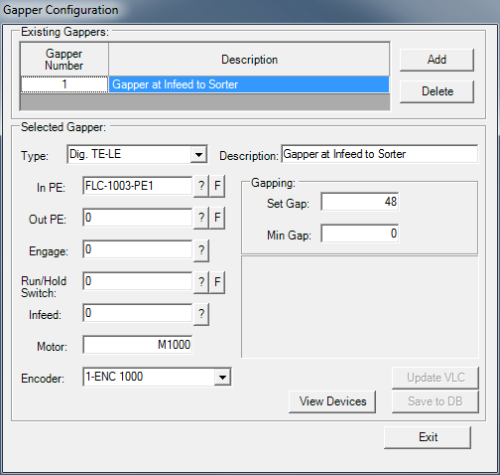
Figure 20 Configure Gappers

Sorter Setup Procedure

Set up ZMC

Add Encoders
Use Configuration►Sortation►Encoders
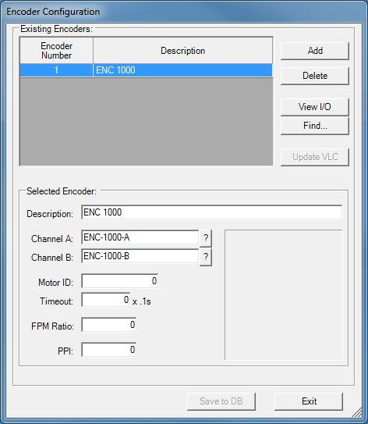
Figure 21 Configure Scanners

Add Scanners
Use Configuration►Sortation►Scanners
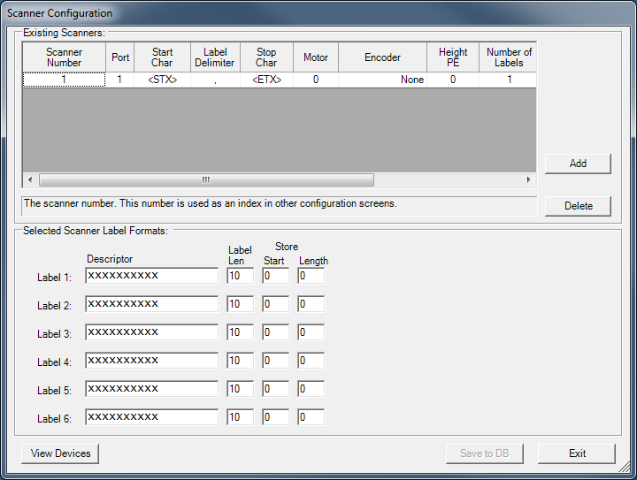
Figure 22 Configure Scanners

Add Production Rate Devices
Use Configuration►Sortation►Production Rate
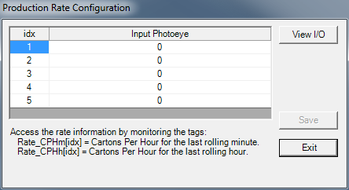
Figure 23 Configure Production Rate

Add Sorters
Use Configuration►Sortation►Sorters
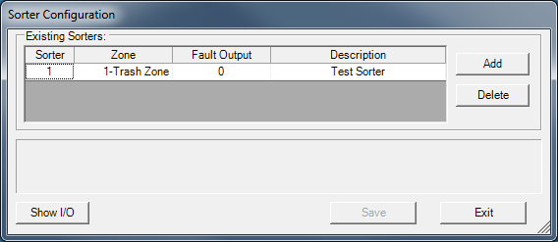
Figure 24 Configure Sorters

Setup the Sorters
Use Configuration►Sortation►Sorter Builder
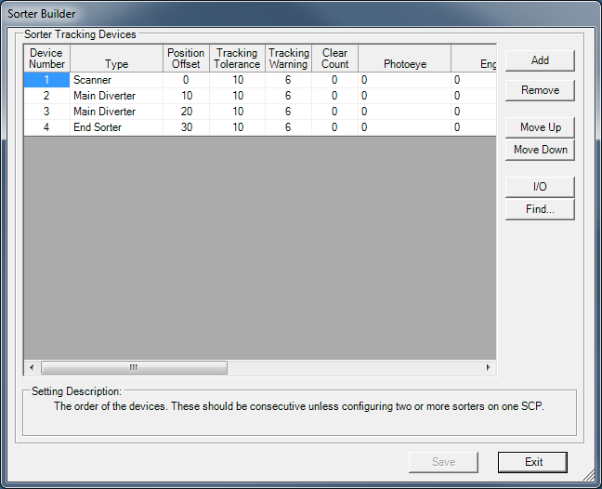
Figure 25 Configure Sorter Builder

Set Up The Lanes
Use Configuration►Sortation►Lanes
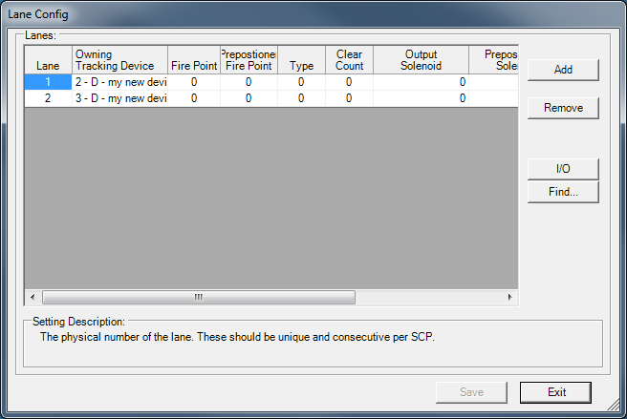
Figure 26 Configure Lanes

Set Up The Lane Full Devices
Use Configuration►Sortation►Lane Full
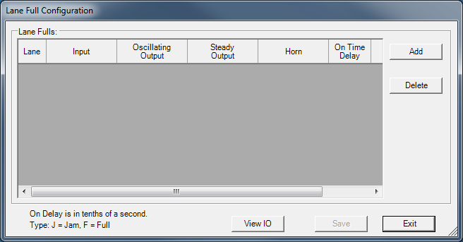
Figure 27 Configure Lane Full

Set Up The Lane Inhibit Devices
Lane Inhibit devices are function blocks that will inhibit a lane if some condition is true. In practical terms, if a divert lane feeds a motor, then that motor must be on. If it isn’t then we need to inhibit the lane from diverting so we don’t create a jam.

Use Configuration►Sortation►Lane Inhibit
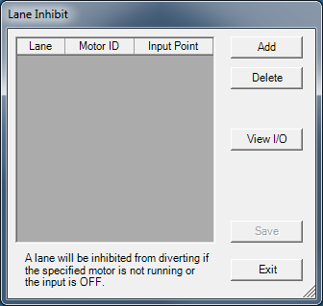
Figure 28 Configure Lane Inhibit

Setup The Shoe Diverters
If this is a shoe sorter, setup the shoe diverters – use Configuration►Sortation►Shoe Sorter►Diverters
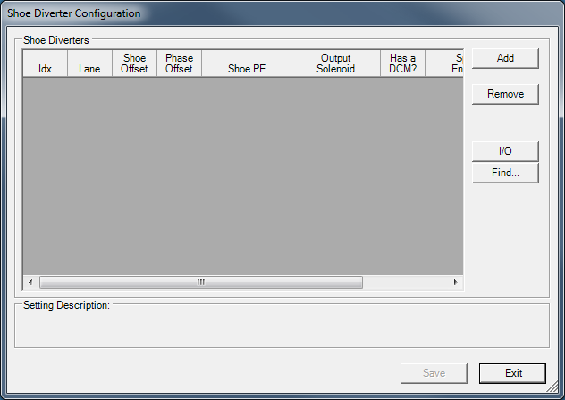
Figure 29 Configure Shoe Sorter Diverters

Add Racetrack Mode
Racetrack mode is a special condition on sorters that form a loop. When there are a high number of recirculated cartons, the sorter can become “locked” in that cartons aren’t diverting, so the sorter recirc line backs up and shuts down the sorter. But, you need to divert cartons to get them out of the recirc system. This is a catch-22.
This screen allows you to configure a logic routine that checks for this situation and automatically initiates “racetrack” mode. This will disable all merge infeeds except the recirculation infeed until the system clears out.

Use Configuration►Sortation►Racetrack Mode
Requires merges be configured first
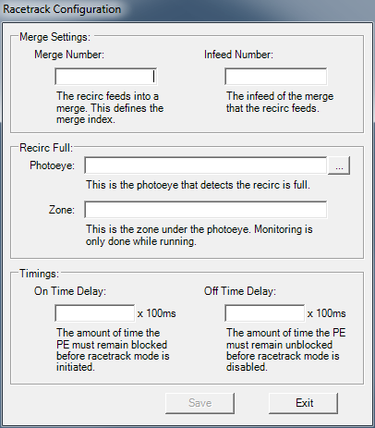
Figure 30 Configure Racetrack Mode

