
SDI Industries - 3000 Pierce St. Pacoima, CA. 91331 - T: 818-890-6002 - F: 818-890-2858

CSS
Trolley Sorting System
Training Guide

April 1, 2013

NOTICE
THIS DOCUMENT BELONGS TO SDI INDUSTRIES, INC. IT IS CONSIDERED A TRADE SECRET AND IS NOT TO BE DIVULGED OR USED BY PARTIES WHO HAVE NOT RECEIVED WRITTEN AUTHORIZATION FROM SDI INDUSTRIES, INC.

COPYRIGHT NOTICE
Copyright © 2013 SDI Industries, Inc.
All Rights Reserved

Table of Contents
1 Introduction 2
2 Configuration 3
2.1 SCP Workstation 3
2.2 Control Cabinet 4
2.3 Sorter Lane 4
2.4 Scanner 4
2.5 NR/NI Lane 4
3 SCP Workstation Startup 5
3.1 Cold Boot 5
3.1.1 Start the SCP Workstation 5
3.2 Warm Boot 5
3.2.1 SCP 5
3.2.2 CSS Screens 5
3.2.3 Windows 5
3.3 End of Day 5
3.4 Beginning of Day 6
4 Tracking 7
4.1 Scan Point 7
4.2 Tracking Switch 8
4.3 Confirmation Switch 9
5 CSS Set Up 10
5.1 Basic Trolley Sorting 10
5.2 CSS Main Screen Stats Tab 10
5.3 CSS Main Screen Store Mapping Tab 13
5.4 CSS Main Screen Reports Tab 14
5.5 CSS Main Screen Alarms and Events Tab 16
5.6 CSS Maintenance Windows Event Log 18
6 Problem Determination and Resolution 20
6.1 Starting the Sorter 20
6.2 General Sorter Operation 20
6.3 Trolley Sorter Operation 21
7 Table of Figures 22

Introduction
This document is a guide to the use of the Trolley Sortation System (CSS) developed by SDI. This Training Guide instructs the operator of the trolley sorter how to operate the sorter during typical production operations. This guide does not address the full functionality of CSS or the mechanical operation of the sorter. Refer to the CSS User’s Manual for more comprehensive information.

Configuration
The Trolley Sorter is comprised of:
- An Sorter Control Processor (SCP)
- Scanner
- Control Cabinet
- Lanes
- NR/NI Lane

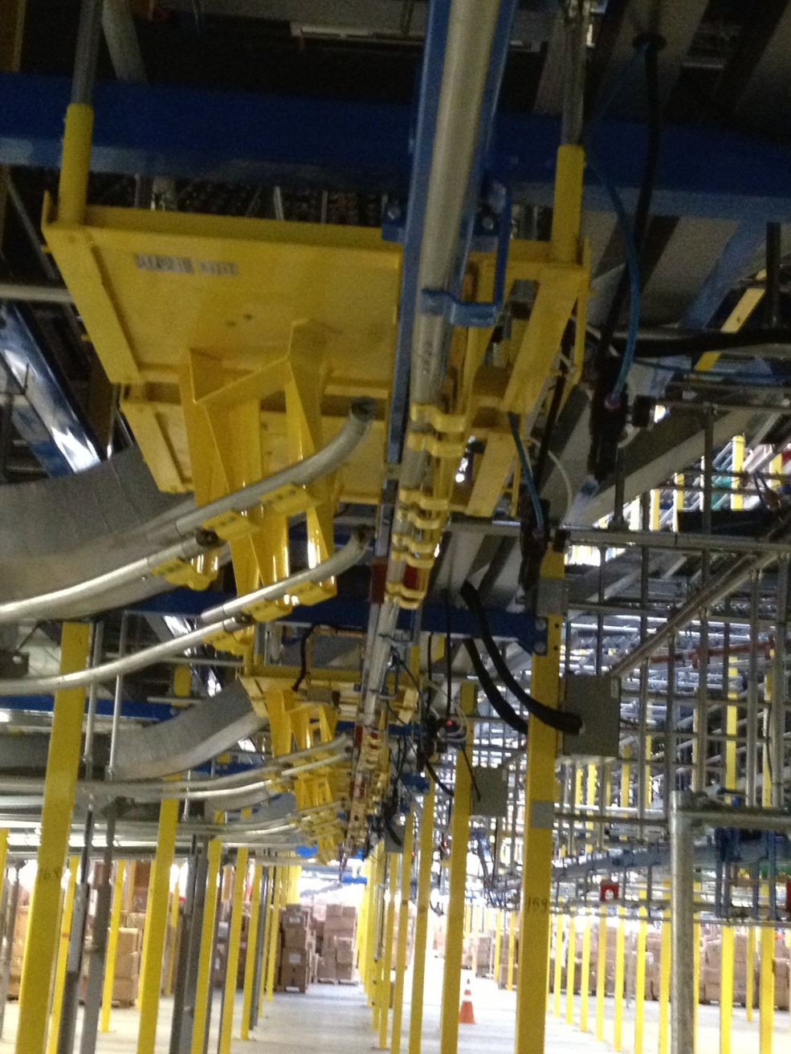
Figure 2-1 Typical Trolley Sorter

SCP Workstation
Jarvis Webb controls run the trolleys on the sorter.
The SCP program receives signals from tracking devices and sends signals to actuating devices to control the physical operation of the sorter.
The User interface screens on the SCP enable an operator to configure the sorter and monitor trolley sorting.

Control Cabinet
The SCP cabinet houses the electronic devices connected to the workstation and the sorter.

Sorter Lane
The sorter consists of a central liner for trolleys branching off to various lanes that receive the trolleys. Each lane is assigned at least 1 store and may include more. A store can be assigned to only 1 lane.

Scanner
A scanner mounted parallel to the trolley and after the Gapper reads the barcodes on the trolleys so the destination lane can be retrieved for the trolley.

NR/NI Lane
Typically the first lane up the line from the induction station is designated as the NR/NI (No Read/Not Identified) lane. When the sorter cannot determine where to send a trolley, it routes it to the NR/NI Lane. For example if the barcode label is not readable or no destination found, CSS routes the trolley to the NR/NI Lane.

SCP Workstation Startup
Procedures for starting the SCP Workstation must be completed to begin induction operations. A basic knowledge of computers is necessary to start up the system. The exact procedure depends on the state of the system at startup time.

Cold Boot
A Cold Boot is the process of turning a computer on and bringing it up to an operational state when it has been completely turned off.

Start the SCP Workstation
The SCP Workstation receives power from the sorter motor control cabinet so the power to the cabinet must be turned on before starting the workstation or from building power
To start the workstation:
Turn on SCP workstation monitor.
Turn on the SCP workstation. The workstation logs onto CSS and starts all required processes automatically. This may take a few minutes. A special program called Steeplechase VLC must start as the system boots. When booted, the monitor displays a standard Windows Desktop. To verify Steeplechase VLC is running find the Steeplechase VLC Maintainer icon on the desktop and double click on it. The Steeplechase screen is displayed and there should be a status indicator at the bottom right corner of the screen.
All the necessary processes start on the workstation automatically.
Press the Sorter Start Button (Green – SSE) or soft start buttons on the HMI.

Warm Boot
Warm boot occurs when the CSS applications are stopped or Windows XP restarts.

SCP
The SCP users a service called SCP_Service and is automatically started an boot time. Under no circumstances should the server be shutdown.

CSS Screens
To shut down CSS screens, select File from the Main menu.
Choose Exit from the list of commands to exit CSS.
Select Yes to confirm the exit command. The Windows desktop is displayed
To start CSS screens, select the Start CSS Apps icon.

Windows
To Restart Windows select Start at the lower left corner of the screen.
Choose Shut Down from the list of commands.
Choose Restart from the list of options.
Choose OK to confirm restart.

End of Day
The End of Day process refers only to the workstation. The operator should:
- Verify all trolleys are delivered to a lane.
- Press the sorter stop button (Red – SSE) or soft stop buttons on the HMI.
- Turn power off workstation monitor
Note: It is NOT recommended that you do anything to the workstation.

Beginning of Day
The Beginning of Day process is only for the workstation. The sorter should be stopped. If the “End of Day” process was done correctly, the operator should:
- Turn on the workstation monitor
- Press the Green Sorter Start Button (Green – SSE) or soft start buttons on the HMI.
- Select Operations from the Main menu
- Select Sorter Control from the list of commands

Tracking
The sorter pushes the trolley along to a Gapper that used to regulate the spacing of the trolleys. The sorter places the trolley onto the sorter at the exact moment when the “hard Dogs” place it into the designed tracking location. A scanner is used to read the barcode and requests a destination. Once a destination reaches the induction point it is tracked to the proper lane and diverted

Scan Point
Once the trolley has be placed onto the sorter, the trolley is scanner for a valid barcode

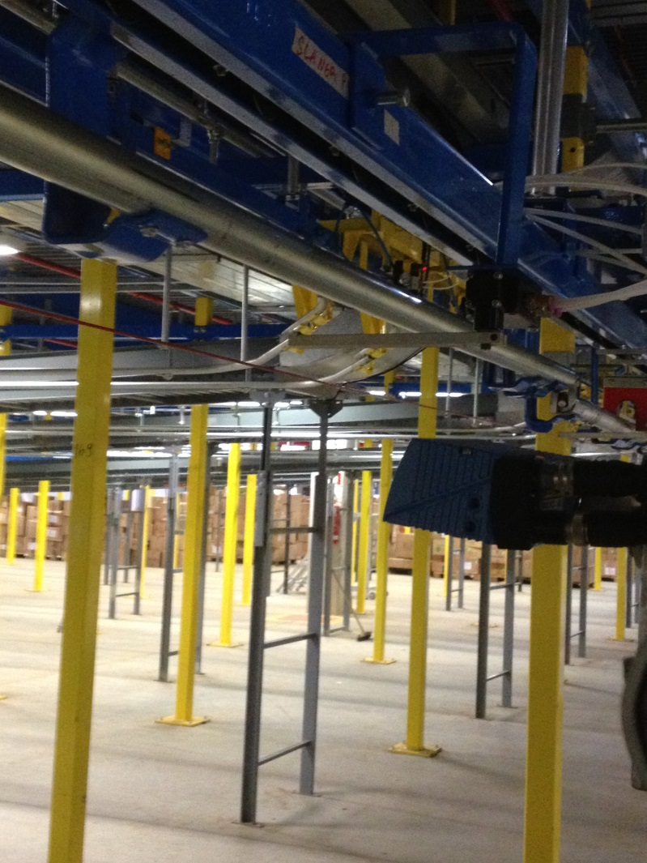
Scan
Point
Figure 4-1 Scan Point

Tracking Switch
Once inducted, a whisker switch is used to signify the beginning of the trolley
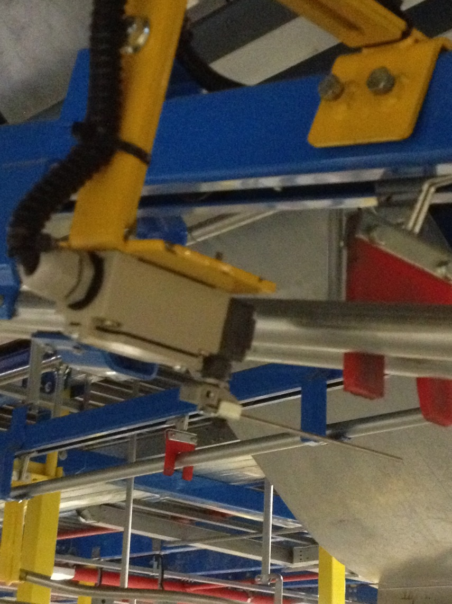
Induction
Whisker
Switch

Figure 4-2 Tracking Switch

Once the leading edge of the trolley is sensed by the whisker the trolley is tracked until it reaches its destination. At the destination, CSS activates the diverter and the trolley is sent down the lane.

Confirmation Switch
At the end of the sorter is another whisker switch that confirms the trolley has diverted.

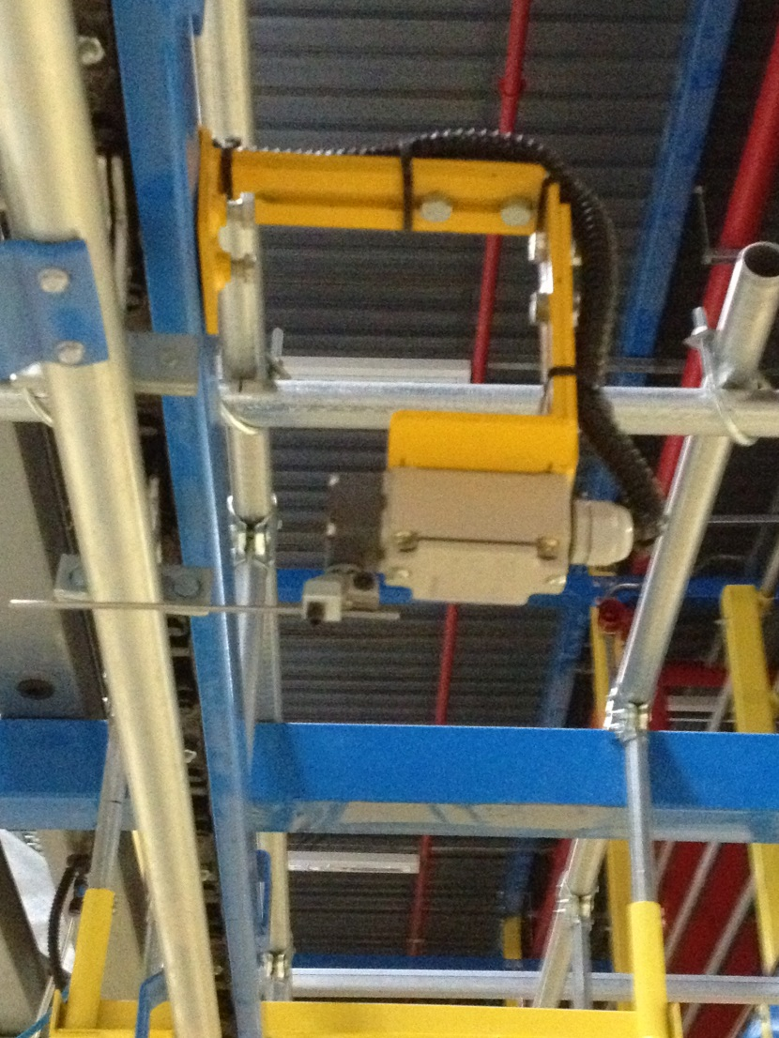
Confirm
Whisker
Switch
Figure 4-3 Confirmation Switch
After the trolley triggers the whisker, CSS sends a divert confirmation.

Depending on the size of the sorter, there may be more than 1 confirmation switch.

CSS Set Up
For full functionality the CSS SCP must be running with the database enabled and the Steeplechase VLC Basesorter program in running mode. Typically this is set to start as the system boots up. The CSS screens application is not required but the screen displays provide real time information related to system operations so the application should be started. If CSS is integrated with a host system or WCS the network must be running and the CSS SCP connection to the network active.

Basic Trolley Sorting
To divert a trolley to the correct destination lane the CSS SCP Basesorter tracks each trolley down the main line from the induction point utilizing input from sensors mounted on the sorter and sends a divert signal to the correct divert actuator at the required time to divert the trolley to the correct destination lane.
When a trolley passes the induction scanner the barcodes read from the trolley are entered into the CSS database. CSS determines if the barcodes is a valid Trolley ID based on the trolley label descriptor configured for the system. Upon validating the Trolley ID CSS routes the trolley based on the sorting mode configured.
When CSS is integrated with a host system upon validating a Trolley ID CSS sends a query to the host for a destination lane. The host receives the query looks up the destination lane for the trolley in its database and returns the destination to CSS. CSS then diverts the trolley at the destination lane specified.
CSS can be configured to look up the store destination in its own database and route the trolley based on a store to lane map managed locally. In this mode the host sends trolley routing files to CSS listing trolleys and the destination stores that are expected at the sorter. CSS processes the files into a local database and upon identifying a trolley at the induction scanner looks up the trolley in the local database determining the store destination. CSS then routes the trolley to a lane to which the store is assigned based on a store to lane assignment set up locally.
CSS can be configured to route trolleys based on data in the barcode label read at the induction scanner. For example if the trolley label descriptor requires a Trolley ID to be a 12 digit integer with the last four digits representing a Store ID then CSS parses the Store ID from the Trolley ID determines the lane to which the store is assigned and sets the destination lane for that trolley in the database. Tracking the trolley as it travels down the sorter when the trolley reaches the correct lane the SCP actuates the divert mechanism and the trolley diverts to the destination lane.

CSS Main Screen Stats Tab
The CSS Main screen Stats tab provides continually updating information related to the operation of the sorter. CSS opens to this display by default.
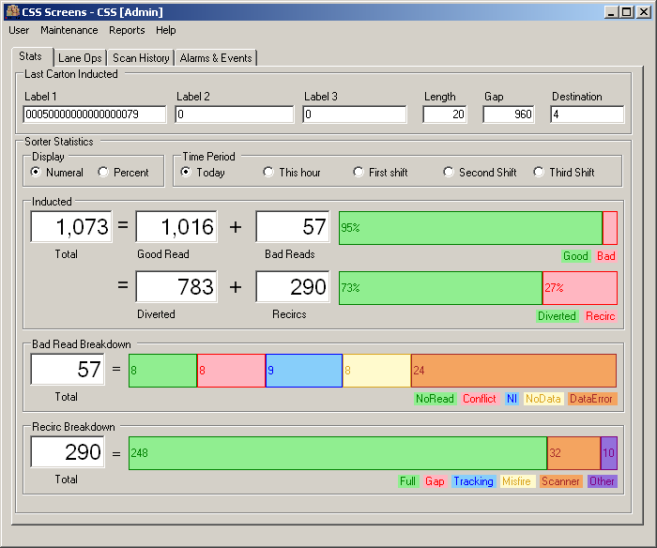
Figure 5-1 CSS Main Screen - Stats Tab
Data displayed on the CSS Main screen Stats tab includes:

Data Field | Description
Last Trolley Inducted
Label 1, Label 2 and Label 3 | Values recorded for label barcodes scanned at the induction scanner
Length | Length of the trolley in a pre-defined unit of measure
Gap | Length of the gap between the preceding trolley and the last trolley inducted
Lane | Destination lane assignment for the trolley
Sorter Statistics
Select time period | Selection of time period for which the statistics displayed are calculated
Select time period | Today | 24 hour period from the configured start of day
Select time period | This hour | Current one hour period from the top of the hour
Select time period | First shift | Time period based on the first shift configuration
Select time period | Second shift | Time period based on the second shift configuration
Inducted | Number of trolleys inducted for the selected
Good Read | Number of trolleys for which the scanner read a valid Trolley ID  The percentage of total trolleys that were Good Reads
Diverted | Number of trolleys for which the SCP initiated a divert to a lane  The percentage of total trolleys for which the SCP recorded a divert
No Read | Number of trolleys for which the scanner failed to read a valid Trolley ID  The percentage of total trolleys that were No Reads
Total Recirc | Number of times the SCP re-circulated trolleys  The percentage of total trolleys for which the SCP recorded re-circulations
Recirc Analysis
Tracking | Number of re-circulations caused by tracking errors  Percentage of the total number of trolleys processed that re-circulated because of tracking errors
Unknown | Number of re-circulations caused by unknown reasons  Percentage of the total number of trolleys processed that re-circulated because of unknown reasons
Gap | Number of re-circulations caused by gap errors  Percentage of the total number of trolleys processed that re-circulated because of gap errors
Not assigned | Number of re-circulations caused because a destination lane was not assigned  Percentage of the total number of trolleys processed that re-circulated because a destination lane was not assigned
Lane Full | Number of re-circulations caused by a full destination lane  Percentage of the total number of trolleys processed that re-circulated because of a full destination lane
Lane Disabled | Number of re-circulations caused by a disabled destination lane  Percentage of the total number of trolleys processed that re-circulated because of a disabled destination lane
Misfire | Number of re-circulations caused by a divert failure  Percentage of the total number of trolleys processed that re-circulated because of a divert failure
Scanner error | Number of re-circulations caused by a scanner error  Percentage of the total number of trolleys processed that re-circulated because of a scanner error

Warning: Only stats for the day can be displayed. Currently there is no option to go back to previous days stats.

CSS Main Screen Store Mapping Tab
The Store Mapping tab enables the user to select stores from a list of stores configured for the system and add them to a Destination Mapping. Stores and Destinations must be entered using the Stores and Lane Editor screens.
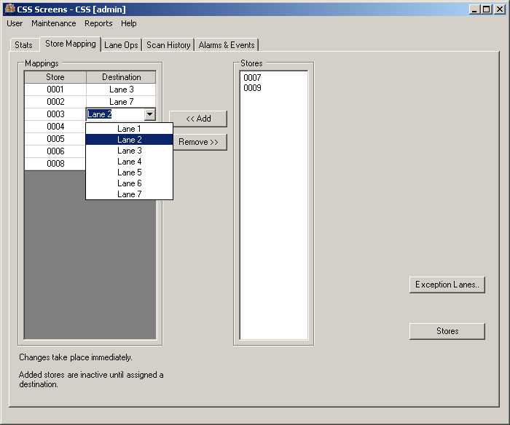
Figure 5-2 CSS Main Screen - Store Map Tab
To add a store to the Mapping select the store from the list of stores and choose <<Add. The selected store moves from the Stores list to the Mappings list.
To remove a store to the Mapping select the store from the list in Mappings and choose Remove>>. The selected store moves from the Mappings list to the Stores list.
To choose a destination for a store in the Mappings list click on the Destination column on the row of the Store you wish to assign. A list of the available configured destinations displays.
Choose the destination from the list and the assignment takes effect immediately.
To access the Lane Editor screen choose Destinations.
To access the Stores screen choose Stores.

CSS Main Screen Reports Tab
CSS generates certain pre-configured statistical reports for operations within a specified time frame. The reports collect the statistics displayed on the CSS Main screen Stats tab for the time frame specified except the Lane Stats report which collects data related to the sorter lanes.
To generate reports select the Reports tab on the CSS Main screen to access Reports functions.
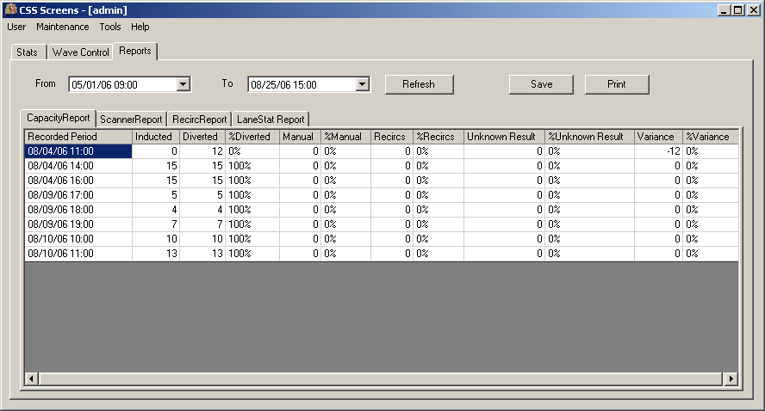
Figure 5-3 CSS Main Screen - Reports Tab
To configure a report select the desired report tab, define a time frame by selecting a date and time in both From and To then choose Refresh.
To save the report as a Microsoft Excel spreadsheet file choose Save….
to print the report choose Print….
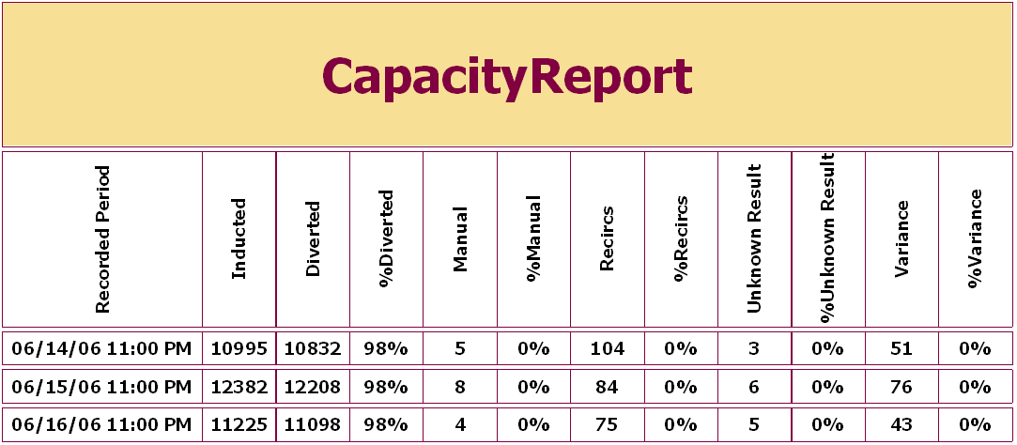
Figure 5-4 CSS Capacity Report
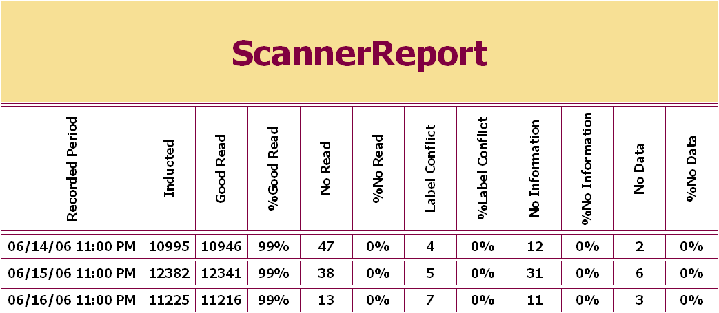
Figure 5-5 CSS Scanner Report
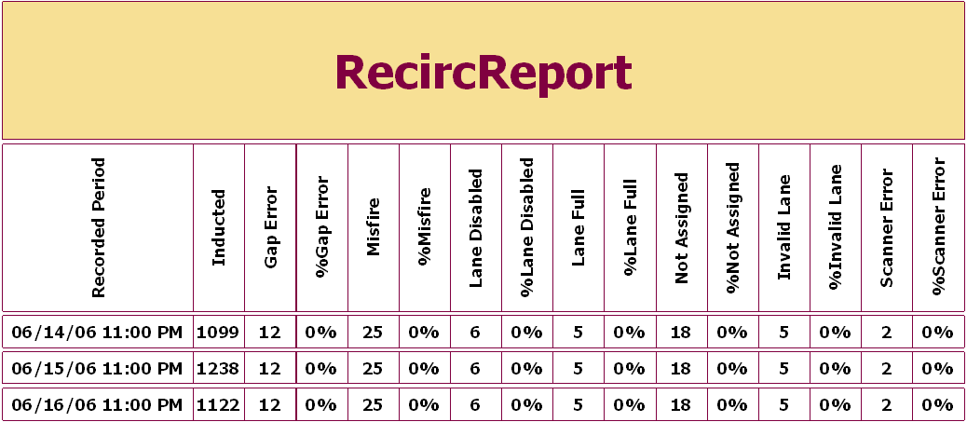
Figure 5-6 CSS Recirc Report
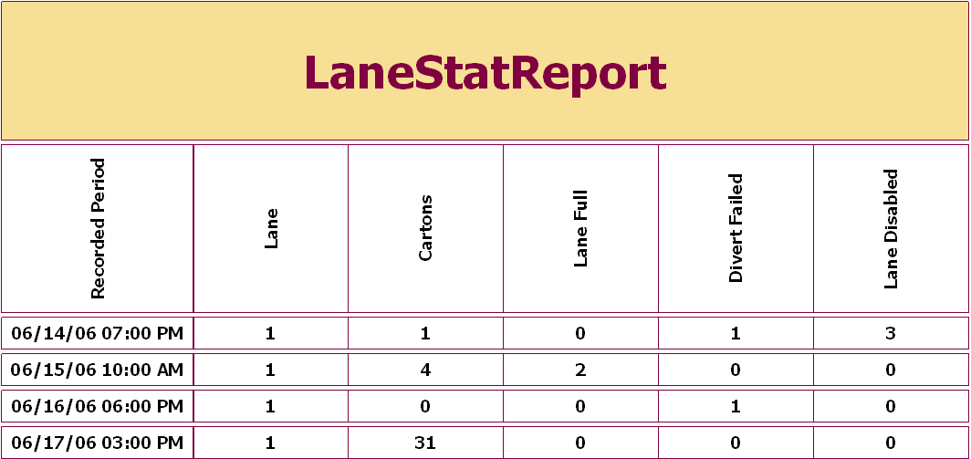
Figure 5-7 CSS Lane Stats Report

CSS Main Screen Alarms and Events Tab
The CSS Alarms and Events Tab displays information related to the 50 most recent events occurring with the system. There are many types of events the system records and the events can be filtered by Event Type to limit the list when searching for an event.
Events provide a valuable diagnostic tool to determine why the system may have erred.
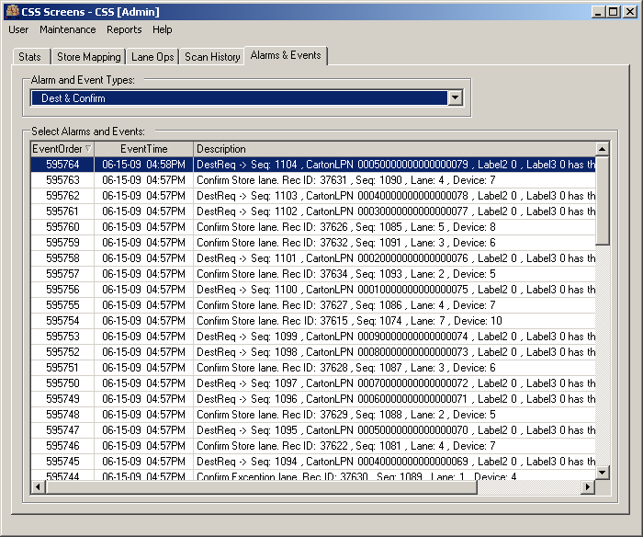
Figure 5-8 CSS Main Screen Alarms and Events Tab
Alarms and events default to display All Event Types.
To filter the event list by Event Type select an Event Type in Alarm and Event Types. Based on the selection Selected Alarms and Events updates immediately and displays the associated data.
Event Types include:

Data Field |  | Description
Sorter | Events related to the physical state of the sorter
Sorter | Start/Stop |  | Sorter start and stop events
Sorter | Gapping |  | Sorter events related to the gapping function
Sorter | Scanner |  | Sorter events related to the scanner function
Sorter | Weight |  | Sorter events related to the scale if present
Sorter | Destination/Confirmation |  | Sorter events indicating destination assignments and divert confirmations
Sorter | Tracking |  | Sorter events related to the tracking errors
Sorter | Lane Full |  | Sorter events related to the Lane Full conditions
Sorter | Re-circulation |  | Sorter events related to trolley re-circulation
System | Events related to system operation
System | All zones Start/Stop |  | Events related to sorter plus in feed and out feed line stopping or starting
System | Jams |  | Events related to trolley jams

CSS Maintenance Windows Event Log
Since the CSS SCP Service application runs as a Windows Service CSS provides a means to directly view the Windows Events related to the SCP Service. To view the Windows event log select Maintenance ► Event Log - Sorter from the CSS Main screen menu bar to open the System Event Log Viewer screen.
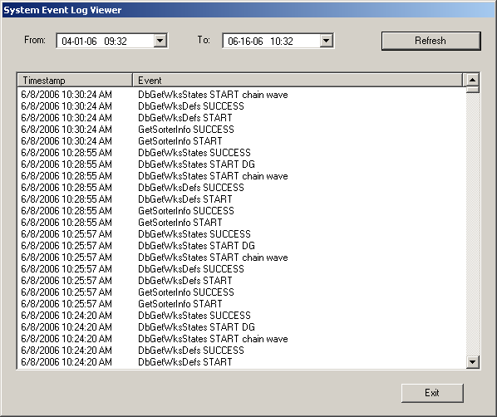
Figure 5-9 View Event Log Screen
To view events select the desired date and time to start and end the list of events in From and To then choose Refresh. The list displays the time of the event and a description of the event.
To exit the System Event Log Viewer screen, choose Exit.

Problem Determination and Resolution
This section provides tips for to assist the operator when the sorter does not operate in a “normal” manner. It is understood that “normal” differs from individual to individual and from site to site. This section deals with general sorter operations.
The following areas are addressed:
- Sorter Starting
- General Sorter Operation
- Trolley Sorter Operation

Starting the Sorter
Should the sorter fail to start, follow the steps below.
Step # | Operation | Yes – Action | No – Action
 | Press Start Button (SSE) | Sorter should Spin – Done | Proceed to the next step
 | Check All E-Stops and reset | Press Start Button (SSE) | Proceed to the next step
 | Is induction screen on? | Proceed to the next step | Start Induction application
 | Did Screen come out of sleep mode? | Proceed to the next step | Reboot system
 | Is workstation power off? | Turn workstation on. | Call SDI support
 | Do Gapper does not go up or down? | Proceed to the next step | No air – call maintenance
 | Sorter starts but stops after 5 seconds | Check for jam trolley on sorter

General Sorter Operation
Question: | When pressing the start button, the horn does not sound
Answer: | - The horn may be broken – call maintenance  - The horn volume may have been turned down. This is a violation of OSHA and must be fixed immediately – call maintenance  - Steeplechase VLC is not running  - SCP applications are not running
Question: | When pressing the start button the horn sounds, but the sorter does not turn.
Answer: | - The motor bypass switch may be turned off. Stop the sorter and call maintenance  - Power problem in SCP cabinet – call maintenance  - The sorter may be jammed – press the stop button and call maintenance  - Inverter overload
Question: | When pressing the start button the horn sounds, the sorter starts but shuts off in about 5 seconds.
Answer: | - There is a jam on the sorter. Press the E-STOP button and investigate. The jam must be cleared before sortation can restart. Maintenance should be called to inspect the sorter for damage. If any damage has occurred, DO NOT use the sorter and call SDI for assistance.  - The encoder or timing device is slipping or defective giving a false jam condition. Call maintenance.  - Certain lanes can be configured to stop when sorter when they are full like recirculation.

Trolley Sorter Operation
Question: | Trolleys Re-circulate on the sorter constantly.
Answer: | - Destination Lane is full  - Barcode label is not readable  - Multiple barcode labels have been read on trolley – scanner is out of alignment
Question: | Items are dropping at NI
Answer: | - Barcode is invalid or more than 1 exists

Table of Figures
Figure 2-1 Typical Trolley Sorter 3
Figure 4-1 Scan Point 7
Figure 4-2 Tracking Switch 8
Figure 4-3 Confirmation Switch 9
Figure 5-1 CSS Main Screen - Stats Tab 11
Figure 5-2 CSS Main Screen - Store Map Tab 13
Figure 5-3 CSS Main Screen - Reports Tab 14
Figure 5-4 CSS Capacity Report 15
Figure 5-5 CSS Scanner Report 15
Figure 5-6 CSS Recirc Report 16
Figure 5-7 CSS Lane Stats Report 16
Figure 5-8 CSS Main Screen Alarms and Events Tab 17
Figure 5-9 View Event Log Screen 19

